

SA-SAMS

Guidelines for using the Security and Database function module

August 2009

Education Management Systems (EMS)
Department of Education
Private Bag X895
0001 PRETORIA

CONTENT

1. INTRODUCTION 3
2. GETTING STARTED 3
3. THE STRUCTURE OF SECURITY AND DATABASE FUNCTION 4
3.1 Maintain system user 4
3.2 Database Functions 12
3.2.1 Export Data Fields to MS Excel 13
3.2.2 Compacting the Database 14
3.2.3 Microsoft Backup Utility 15

INTRODUCTION

The Security and Database module is solely meant for the administrative purposes of both the system users and database maintenance. The processes for securing the programme which covers the security or access to confidential data are discussed below. The school SMT and SGB will not want unauthorised persons accessing the information on this particular computer.

GETTING STARTED

Click on the Security and Database Function button to start.

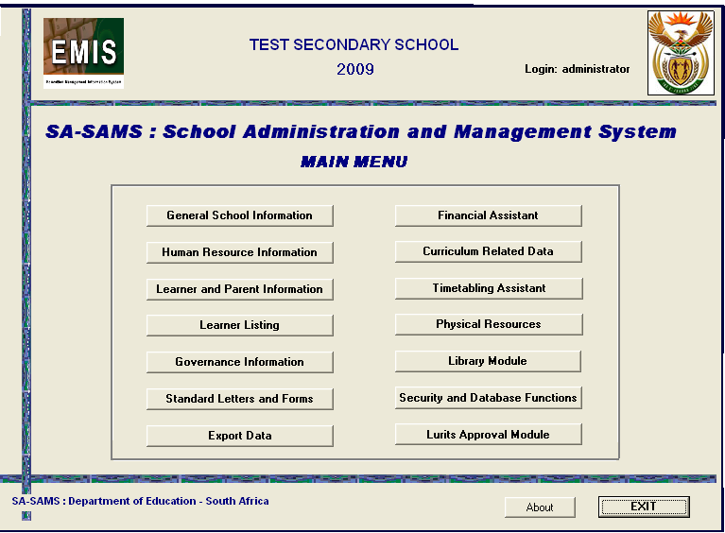
Figure 1: SA-SAMS Main menu

THE STRUCTURE OF SECURITY AND DATABASE FUNCTION

- Click on Security and Database Functions (please see figure 1 above) button on the Main Menu;
- The Select Option screen opens; and
- Two options are available.

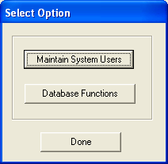
Figure 2: Security & Database Select Function

Maintain system user

- Click on the Maintain System Users button (Figure 2);
- The Maintain Users window will open by launching the window on figure 3 below; and this menu can be used to Add, Edit Save, Delete and modify/update both the username/password and their user right.
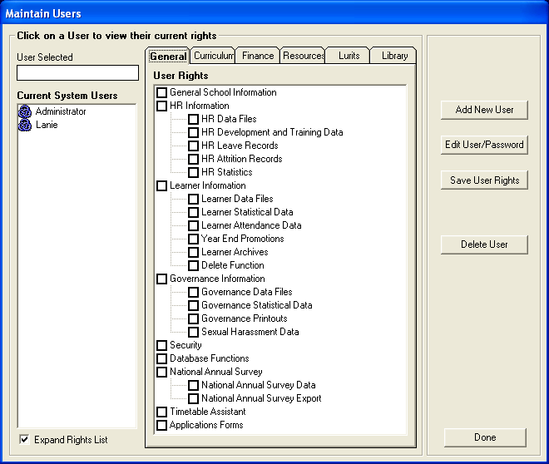
Figure 3: Maintain Users and Rights Window

- The Administrator is the only user that has unlimited control over the whole SA-SAMS system;
- By clicking either of the added user names under the “Current System Users” as shown on Figure 3 above it will enlist all the rights assigned for that specific chosen user, off which the ones that have assigned rights checked turns blue if not they stay black (Please see figure 3 and 4);
Figure 4: Limited Rights User Profile Window

- To register a new user onto SA-SAMS, the administrator would click the “Add New User” button which launches figure 5 below; and
  - For a user to be registered successfully the capturer would type in the “Unique User Name”, “Password”, and “Confirm Password” text boxes and click the “Save” to store the newly entered data into the database.
  - Post to the user being added successfully, the “User Message” box will pop confirming the exercise (Please see figure 8) was done successfully;
  - The next step will be to assign user permissions;

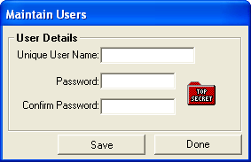
Figure 5: Create Users Windows

  - To assign rights onto the newly added user profile, the capturer would click on the added user’s name (under Current System Users list view in figure 4) in order to activate and populate the user’s to be assigned or already assigned permissions;

Figure 6: Assign User Permission Process Model

  - After the access permissions has been successfully assigned, the new user can exit the SA-SAMS complete and re-login by following figures 4 and 3 above which in this instance will either launch figure 4 above or 7 below depending on permissions assigned;

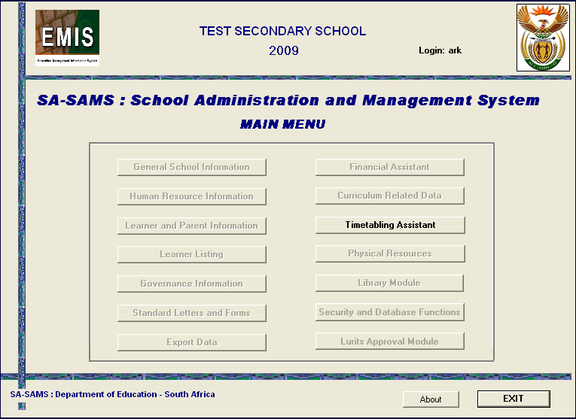
Figure 7: Limited access rights

  - Figure 7 above depicts a logged in user with limited permissions, user “ark” was only allowed to view only the Timetabling Assistant;

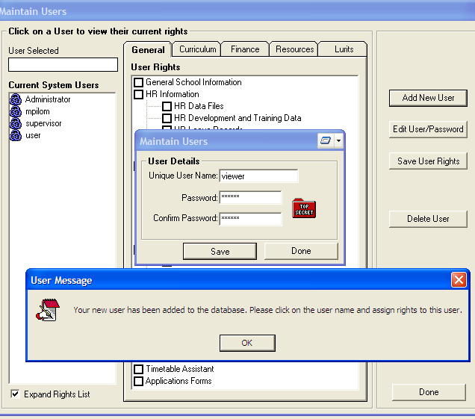
Figure 8: Saving Newly Added User

- To edit a user name or password click on Edit User/Password button as it’s depicted on figure 9 Maintain Users window;

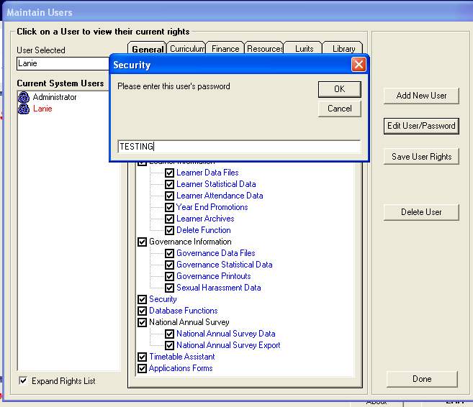
Figure 9: Edit User permissions

- This exercise will prompt the user to re-enter their password in order to confirm if they have rights to do changes on the SA-SAMS user’s module (Please see Figure 10);
  - Parameters to follow when editing/modifying a user:
    - Enter a unique user name if necessary;
    - Enter a new password necessary;
    - Re-enter a new password to confirm the initial one;
    - Log off programme completely by exiting and re-login using the new details; and
    - Passwords are case sensitive; therefore it would be advisable to use small letters for both user name and password.
- After the user has successfully modified the user name or user permissions, a message box will pop up as it can be seen in Figure 10 below;

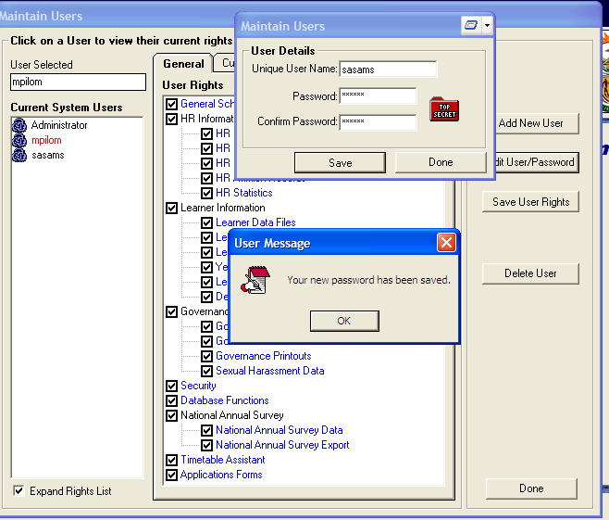
Figure 10: Confirm a successful edit

- If the user wants to delete the added users, he/she will first choose the user to be deleted then click on the Delete User button;
- Before a user can be deleted from the Current System Users list, there will be a message asking the user if they really want to delete the selected user! (Please see figure 11); and

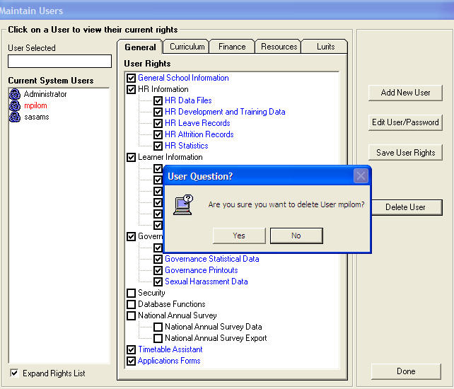
Figure 11: Delete User

- To return to the previous window the user will click the Done button.

Database Functions
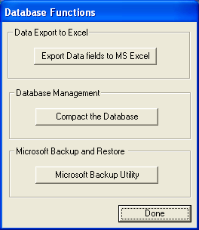
Figure 12: Security and Database Functions

To gain access to this function the user will click on the “Database Functions” button in figure 12 above. After clicking the Database Functions window it will launch figure 13 shown below.

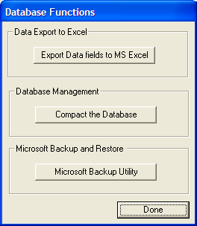
Figure 13: Database Functions Window

The Database Function contains the following sub-database functions:

Export Data Fields to MS Excel

- Click on Export Data fields to MS Excel button
- The following screen opens

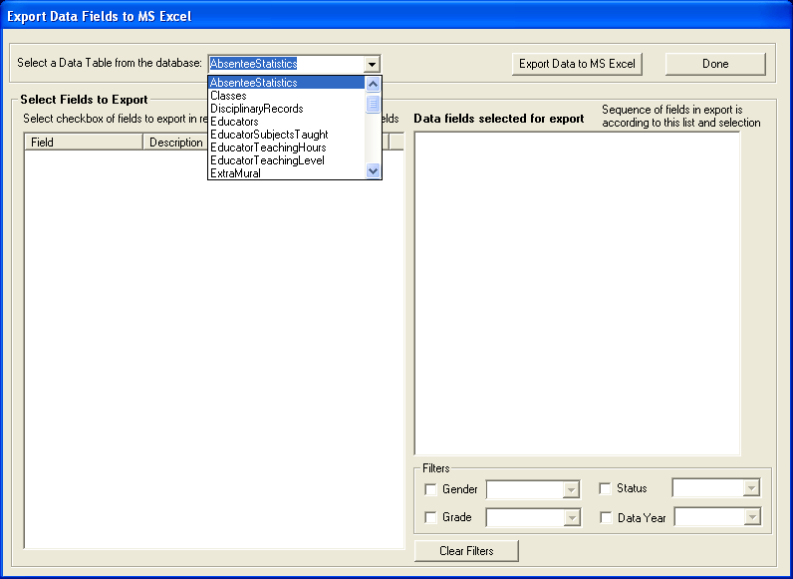
Figure 14: Database Functions Window

- Select from the dropdown menu in the screen picture whichever field you want to export
- The dropdown menu has a list of options not in the screen picture. Scroll down to see other options
- Select data from list that appears in left column by ticking in checkbox
- Selected fields pop over to right column
- Click on Export Data to MS Excel button. You will be asked if you want to view the Spreadsheet now

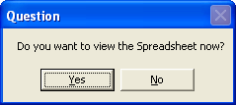
Figure 15: Database Functions Window

- Select Yes, and Spreadsheet opens

Compacting the Database

- To compact your databases, click on the Compact the Database button.
- A user question massage will appear asking you to make sure you make a copy of your database before you continue.

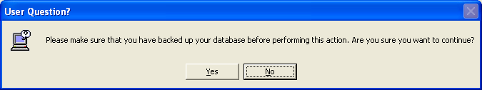
Figure 16: Database Functions Window

- Click on Yes if you have a copy of your database and a massage box will open informing you that your database has been compacted and if you want to use the compacted database click on Yes button.

Microsoft Backup Utility

- Click on Security And Database function on Main Menu
- Click on Database Functions
- Click on Microsoft Backup Utility button

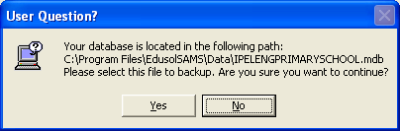
Figure 17: Database Functions Window

- Read the User Message and click Yes
- The page Welcome to the Backup Wizard opens
- Click Next
- Select Back up Files and Settings. Click Next
- Select the option let me choose what to backup and Click Next.
- Tick in the little box with the cross next to My Computer
- Tick in the little box with the cross next to Local Disk (C :)
- Tick in the little box with the cross next to Programme Files
- Tick in the little box with the cross next to EdusolSAMS
- Under EdusolSAMS, click directly on the yellow Data Folder
- On the right screen the school database/s will appear
- Tick in the box next to the school name you wish to backup
- Click Next
- You will be asked the backup destination and name
- Browse for the place you wish to send the files to e.g. A-Drive (3½ flash drive); or CD-Drive (D :)
- Type in the name of the file e.g. 31 Jan2009
- Save
- This information is confirmed in the specific fields
- Click next button and the click finish button.
- If you are using stiffy disks to backup you will need quite a few. As each one fills, the user message will inform you when to insert the next one.
- Please label your disks/CD and store in a safe place

