

**MANUAL - FIX THE BUDGET TO PRINT THE LAST PAGE**

1. Go to Control Panel

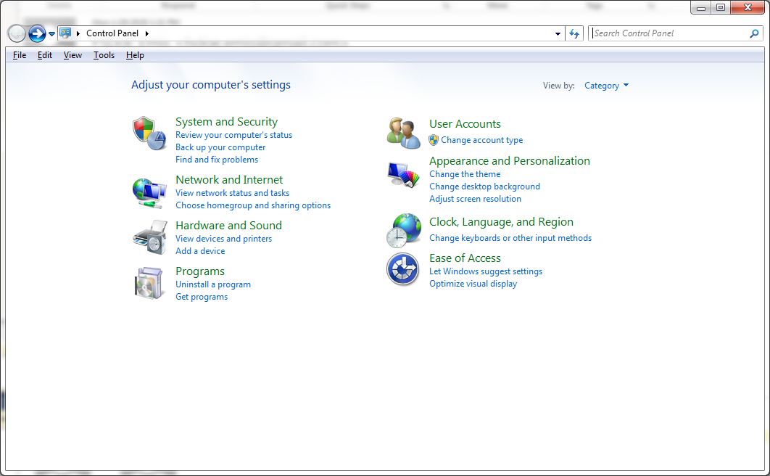

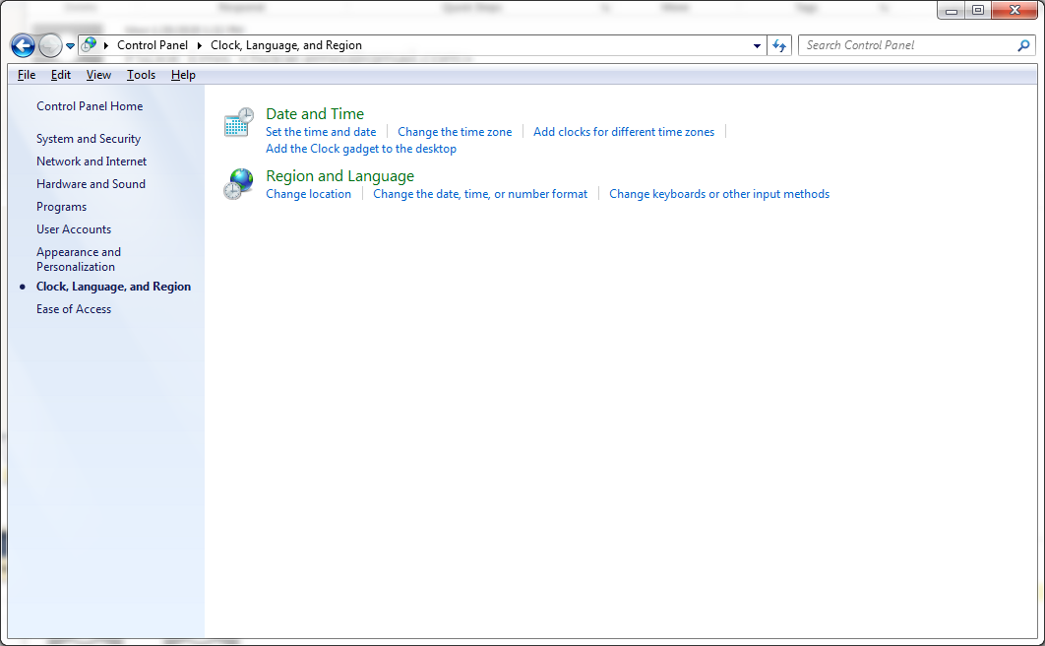

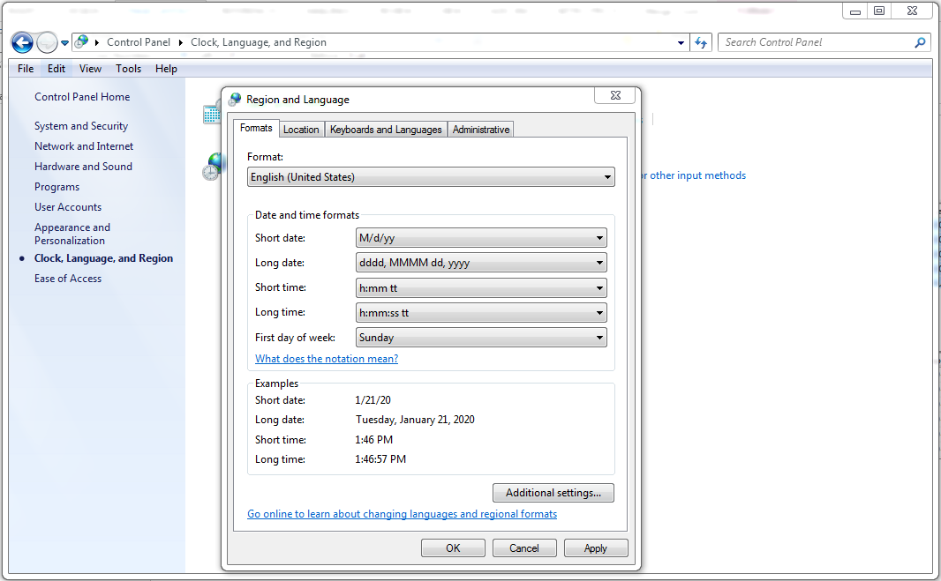

**Click on Additional Settings**

**Change the format to English (United States)**

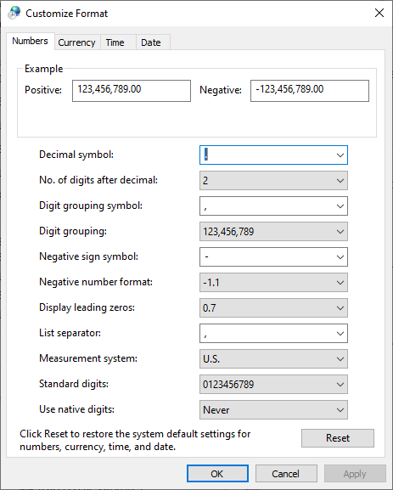

**Click on the Date button**

Type the **short date** as shown in the pic below.

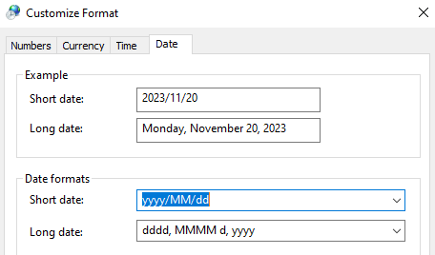

Click **Apply** button and then **OK** button.