

SA-SAMS

Guideline for using Learner and Parent Information module

September 2009

Education Management Systems (EMS)
Department of Education
Private Bag X895
0001 PRETORIA

CONTENT
1. INTRODUCTION 4
2. LEARNER INFORMATION 4
2.1 Learner Information Menu 5
2.1.1 Learner Enrolment Menu 6
2.1.1.1 Add New Learner 7
2.1.1.2 Add Parent to a Learner 10
2.1.1.3 Choose an Option 11
2.1.1.4 Adding Additional Parents to Learners 11
2.1.1.5 Parent Information Page to Add New Parent to Learner 12
2.1.2 View/Update Learner 13
2.1.2.1 Update an Existing Learner 13
2.1.3 Archive a Learner 15
2.1.3.1 Remove a Learner 15
2.1.4 Disciplinary Records 16
2.1.4.1 Maintaining Disciplinary Records for Learners 16
2.1.4.1.1Adding or Editing a Record 17
2.1.5 Incidents 17
2.1.6 Learning Barriers 18
2.1.7 Sport, Art and Culture 19
2.1.8 Marks Archive 19
2.1.8.1 Marks Archive Printout 20
2.1.9 View Family 21
2.1.10 Update Parent Data 22
2.1.10.1 Updating or Viewing Parent Details 22
2.2 Learner Applications 23
2.2.1 Add a New Application 25
2.2.2 Updating or Viewing an Applicant’s Details 26
2.2.2.1 Status 26
2.2.2.2 Update an Application 26
2.3 Learner Grade and Classes 27
2.3.1 Assign Learner to Grade 28
2.3.2 Assign Learner Classes 28
2.3.3 Design Blank Class Lists 29
2.3.4 Class Statistics 30
2.4 SIAS for SNE Learners 31
2.5 Parent Information 31
2.5.1 Parent Information 32
2.6 Learner Family Report 36
2.7 Learner Parent Export 36
2.8 Learner Archive 37
2.9 Delete Entire Learner Record 39
2.10 Maintain Attendance 40
2.10.1 Weekly Learner Attendances 40
2.10.1 Blank Daily Attendance Register 41
2.10.1 Print Daily Absentee 42
2.10.1 View Individual Learner Absences 42
2.10.4.1 Learner Absentees Records 42
2.10.1 Learner Attendance Printouts 43
2.10.5.1 Daily Attendance Details per Learner 43
2.10.5.2 Total Days Absent Per Learner 44
2.10.5.3 Weekly Attendance Summaries per Class 44
2.10.5.4 Quarterly Attendance Statistics 45
2.10.5.5 Quarterly Attendance 45
2.10.5.6 Export File for Learner Attendance 46
2.11 Statistical Data and Reports 47
2.12 Learner Age+ House Group List 48
2.13 Details of SNE Learner 48
2.14 Learner Details Data Printouts 49
2.15 Learner Aggregate Data Printout 49
2.15.1 Export File 50
2.16 Customised Learner Data Fields 50
2.17 Learner Bus Route 50
2.18 Assign Mentor to a Learner 51
2.19 Reporting Language 51
2.19.1 Setting up Afrikaans for Reporting Purposes 51
2.19.2 Entering of NEW Learners onto the system 52
2.19.3 Changing existing learners reporting status on the system 53
2.19.4 Changing Reporting Language under Curriculum Related Data Module 54
2.20 Year End Learner Promotions 55
2.20.1 Process and Maintain Learner Promotions 55
2.20.2 Place Learner in New Grade 56
2.20.3 Grade Class Statistics 57
2.20.4 Process Learner Promotions 57
2.20.5 Promotions Processed 58
2.20.6 Annual Promotion Printout 59
2.20.7 You can printout the promotion stats 60
3. GENERAL REMARKS 60

1. INTRODUCTION

The Learner and Parent information module is a functionality on SA-SAMS that is used to capture biographic and all other information regarding learners and their parents within a school. Information such learner Identity number, residential address, Grades, Class, Age and all other general data relating to learners can be captured, stored, retrieved, edited and processed through this module.

This manual serves to guide and assist SA-SAMS users on how to best apply and functionally use this module in order to achieve the best desired results of the SA- SAMS Leaner and Parent module.

2. LEARNER INFORMATION

Click the Learner and Parent Information button from the SA-SAMS main menu to start using the Learner and Parent information module. (Learner Information Menu will open See Figure 1:

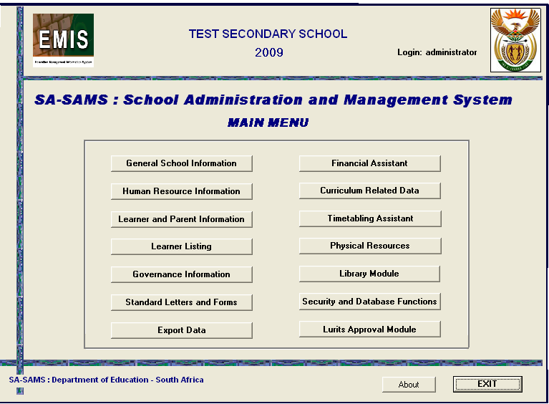
Click to Start the Learner and Parent module.
Figure 1: SA-SAMS Main Menu

2.1 Structure of the Learner Information

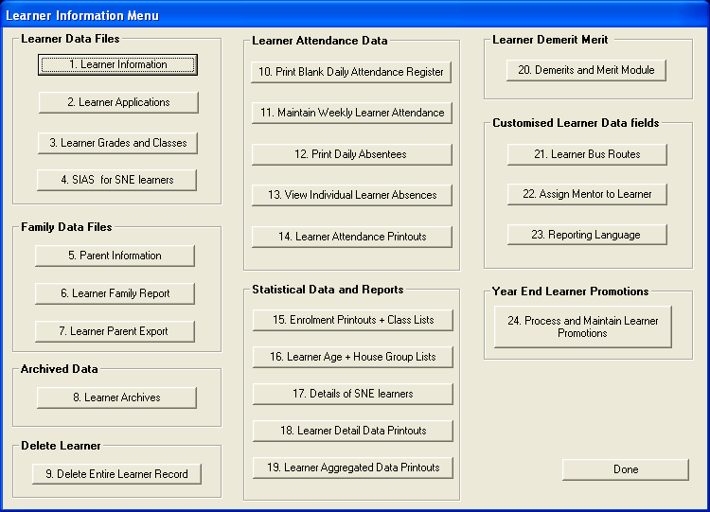
Figure 2: Learner Information Menu

- To start using the Learner Information sub-module, Click on Learner Information button from the Learner Information Menu on Figure 2 above. A Learner Enrolment window will appear as on Figure 3 below.

2.1.1 Learner Enrolment Menu

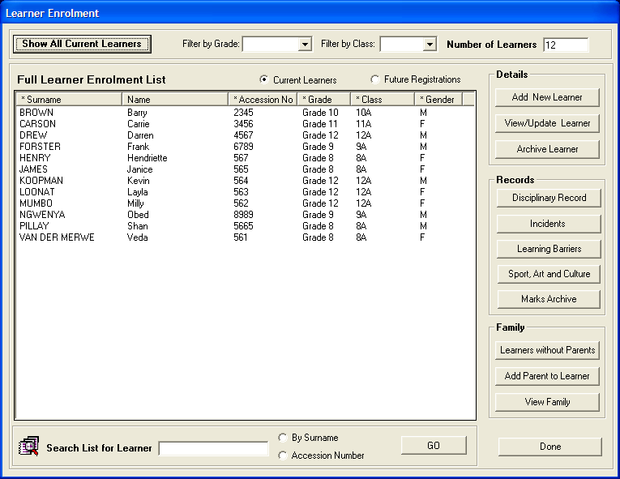
Figure 3: Learner Enrolment

- The Learner Enrolment window opens with a view of all learners in the lowest grade in the school;
- To view learners in other grades, select the required Grade from the Filter by Grade drop down list;
- To view learners in specific classes, select the required class from the Filter by Class drop down list;
- To view all learners in the school, select Show All Current Learners button in the top left hand of the screen. The Number of Learners enrolled at your school will be indicated in the top right corner of the screen;
- This screen has the option to work with Current Learners (this year) or Future Registrations. Future Registrations would be the waiting list of learners who have applied to your school for entry for the following year; and
- The headings listed on the right of the screen indicate the options for data capturing of learner information.
- Users can search for Learners by Surname or by Accession Number through the Search List for Learner facility on the bottom left corner of the screen.

2.1.1.1 Add New Learner

- Click on Add New Learner button to open the Learner Information window; (Figure 4 below appears to requesting a Tracking number if learner is already on LURITS)

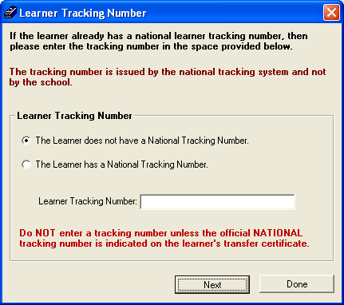
Figure 4: Learner Tracking Number

- A Learner Tracking Number is a 9 digit National Tracking Number which is allocated to learners by the LURITS (Learner Unit Record Information and Tracking System).
- Learners who have not been captured on LURITS will not have tracking numbers. For this learner, select The Learner does not have a National Tracking Number and click on next. (Figure 5 will appear below.)
- Only learners who have been captured on LURITS before will have tracking numbers, for this learner select The Learner has a National Tracking Number, Type in the tracking number on the text box allocated and click on Next. (Figure 5 will appear below.)

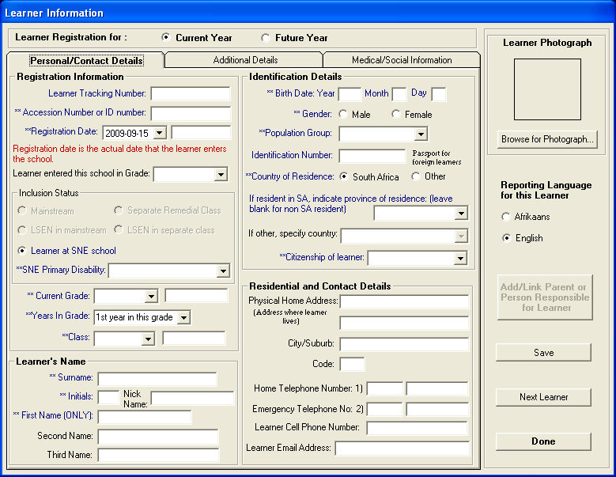
Figure 5: Learner Information

- To continue capturing the learner, Complete all the learner’s details in the relevant fields on Figure 5 above and click on Save button to save your data. All fields marked in blue are compulsory fields and must be completed before you can save your data;
- Please ensure that the Reporting Language option is completed;
- Learner’s photographs can be scanned and stored on the computer or browsed for from another location;
- Click on Additional Details tab to complete further required fields, (figure 6 below will appear)

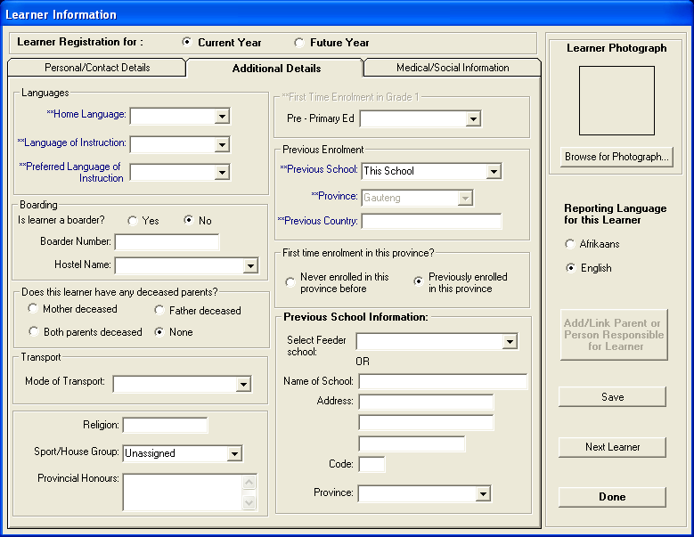
Figure 6: Leaner Information (Additional Details)

- Once you have captured Additional Details, Click on Medical/Social Information (Figure 7 below will appear) tab to capture medical and social information for the learner. In this section none of the fields are compulsory. The information should be captured only if available.

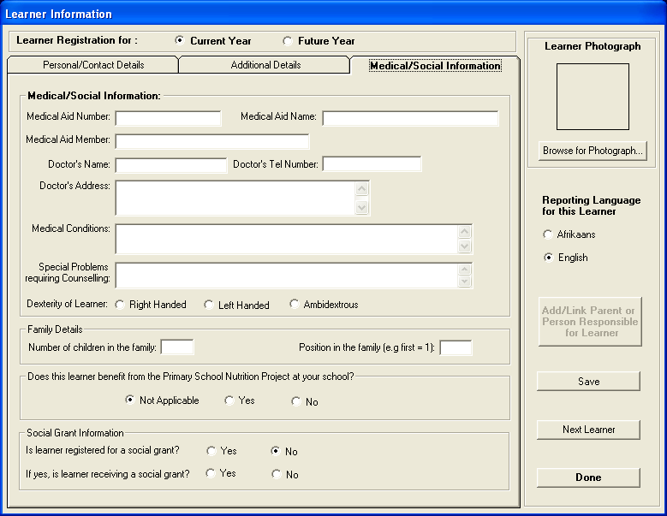
Figure 7: Learner Information (medical and social information)

- Once all the necessary learner information is captured, click on Save button to save your data.
- Once you have saved the learner’s details, it is compulsory to add at least one parent onto the system for each learner; and
- You may add a new parent for the learner or you may link the learner to an existing parent. (Parent previously added to the system for another learner).

2.1.1.2 Add Parent to a Learner
- Once you have saved the learner’s details, you will notice that the Add/Link Parent button turns yellow;
- Click on this button to add or link a parent to the current learner; and
- The Search Parent Option window opens.

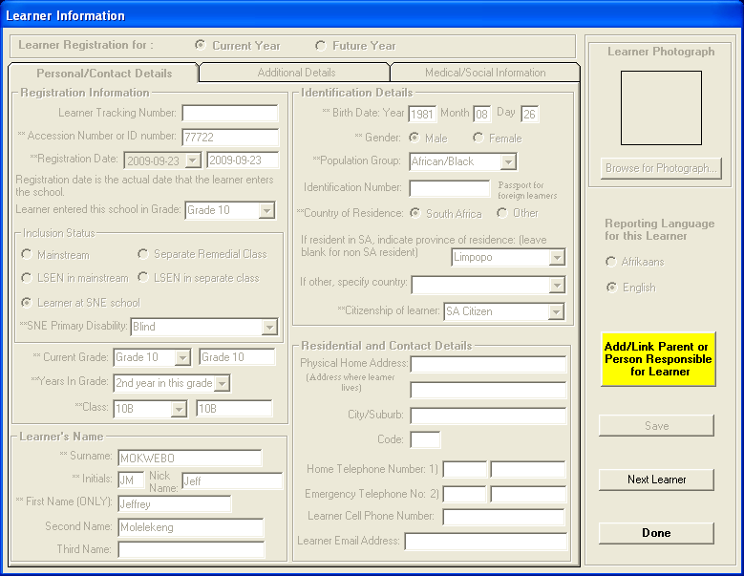
Figure 8: Add parent to learner

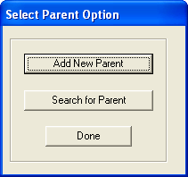
Figure 9: Select Parent Option

2.1.1.3 Choose an Option
- You will now be offered a choice as to whether you want to add an entirely new parent for this learner or whether you would like to link this learner to a parent who has already been entered onto the system for a sibling in another grade;
- Should you select the Search for Parent option; the parent-listing window will open displaying all the current parents on the system (See Figure 4);
- Search for the parent/s that you would like to add to this learner;
- Place a tick in the checkbox next to the selected parents by clicking in the box; and
- Once you have selected the correct parents for the learner, click on Save Parent to Learner to save the relationship.

2.1.1.4 Adding Additional Parents to Learners
- Additional parents can be added to existing learners at any time;
- In the Learner Enrolment window, click on the name of the learner to whom additional parents need to be added;
- Click on the Add Parent To Learner button and continue with linking an existing parent or adding a new parent to the learner as outlined above; and
- You can also add or link a parent to a learner who does not have parent detail.

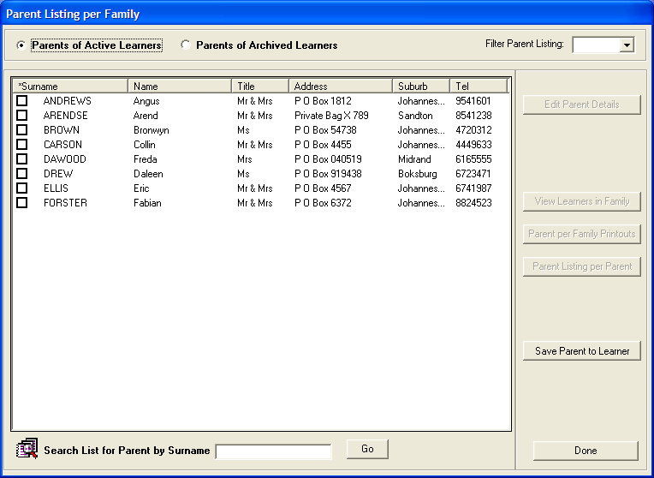
Figure 10: Parent Listing Per Family

- If you are adding a new parent for a learner click on Add New Parent. Complete the parent information on the page that opens.

2.1.1.5 Parent Information Page to Add New Parent to Learner
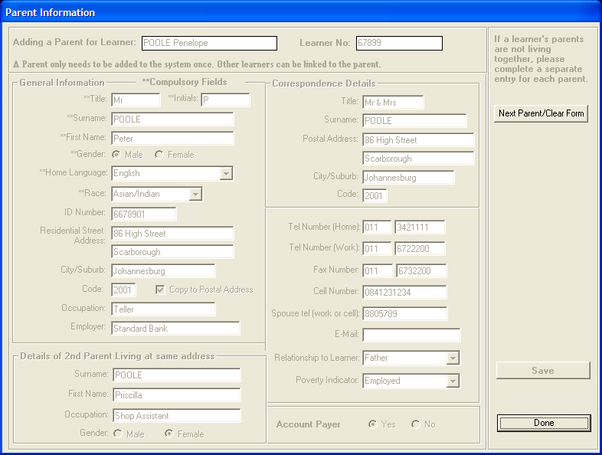
Figure 11: Parent Information

- Complete all the details for the parent and Save your data;
- In the case of learners whose parents are not living at the same address, once you have saved the first parent’s details, you can add another parent for the same learner by clicking on Next Parent button or you can exit the parent information form by clicking on the Done button;
- This takes you back to the grayed out Learner Information page; and
- You can now choose to add another learner by clicking on the Next Learner button or you can return to the Learner Enrolment window by clicking on the Done button.

2.1.2 View/Update Learner
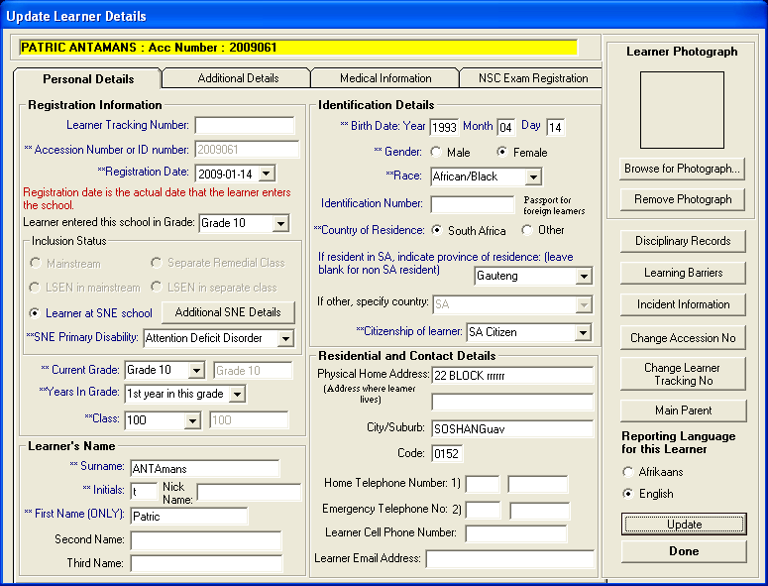
Figure 12: Update Learner Details

2.1.2.1 Update an Existing Learner
- In this window you can update a learner’s details;
- You can change the accession number or other information that the learner needs to have updated.
- Click on the NSC Exam Registration tab to capture or Edit registration information for National Senior Certificate Examination. (See Figure 13 below)
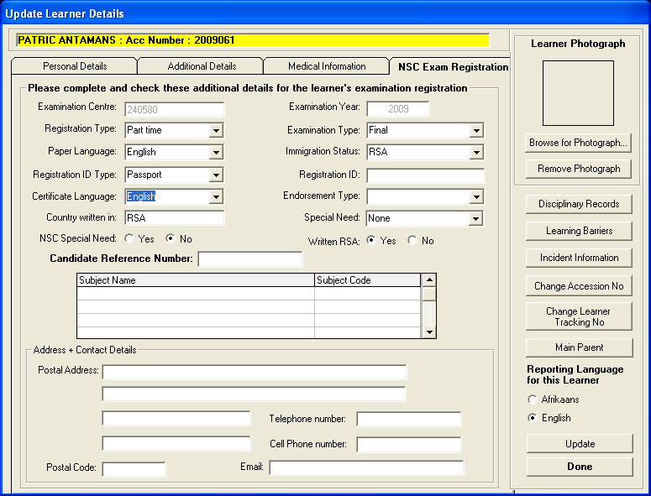
Figure 13: Update Learner Details (NSC Exam registration)

- If all information is captured, click the Update button to save the information.

2.1.3 Archive a Learner

- To archive a learner, select a learner you whish to archive from the Learner Enrolment window (Image 14 below), and Click on Archive Learner.

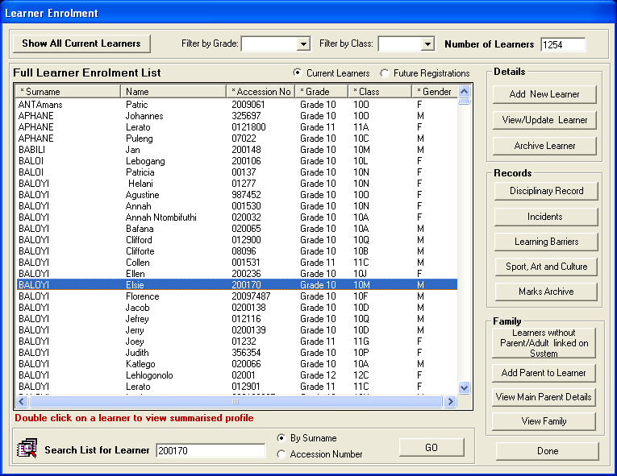
Figure 14: Learner Enrolment (Archive Learner)

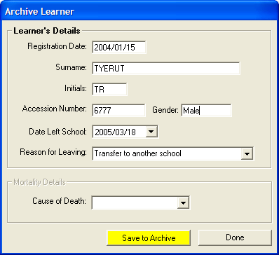
Figure 15: Archive Learner

Remove a Learner

- In order to remove a learner from the current enrolment of a school, you have to archive the learner. Learners cannot be deleted from the system without first being archived;
- A full learner archive is maintained for record keeping purposes;
- From the Learner Enrolment window, click on the name of the learner that you wish to archive;
- Once you have highlighted the name of the relevant learner, select the Archive Learner button;
- You will now be required to give a reason for why the learner is leaving (Figure 8);
- If the reason for leaving is death, you must also state the cause of death; and
- Click on the Save to Archive button to archive the learner.

2.1.4 Disciplinary Records
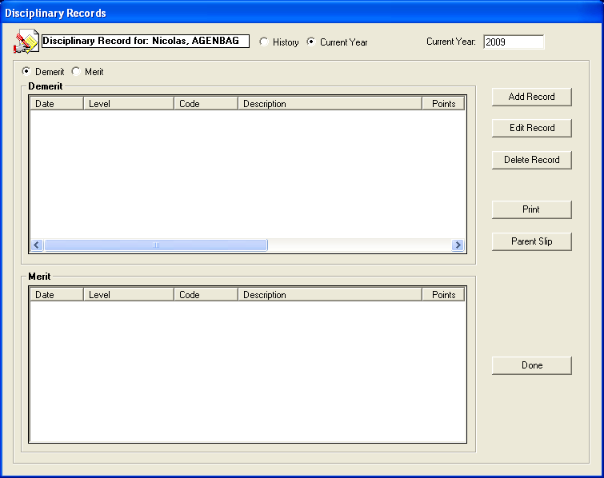 Figure 16: Disciplinary Records

2.1.4.1 Maintaining Disciplinary Records for Learners

- Click on the Disciplinary Records button in the Learner Enrolment window;
- You can add learner misdemeanours so as to keep records of learners who frequently misbehave;
- You can view existing records in the list view;
- In this section you can edit, delete and print learner records; and
- A parent slip/newsletter can be printed and sent to the parents to keep them informed of their child’s behaviour at school.

2.1.4.1.1Adding or Editing a Record

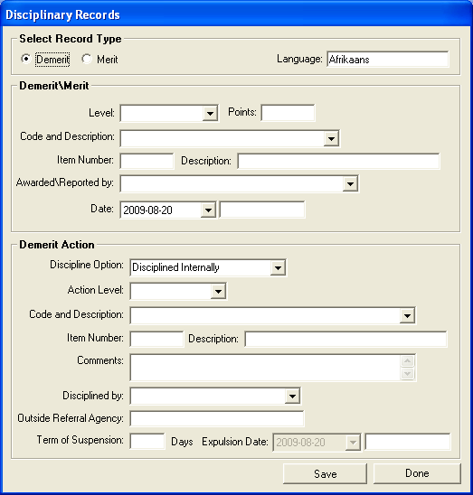
Figure 17: Add Disciplinary Records

- Enter necessary details selecting from the dropdown menus;
- Click on the Save button to save your data; and
- Click Done button to exit.

2.1.5 Incidents
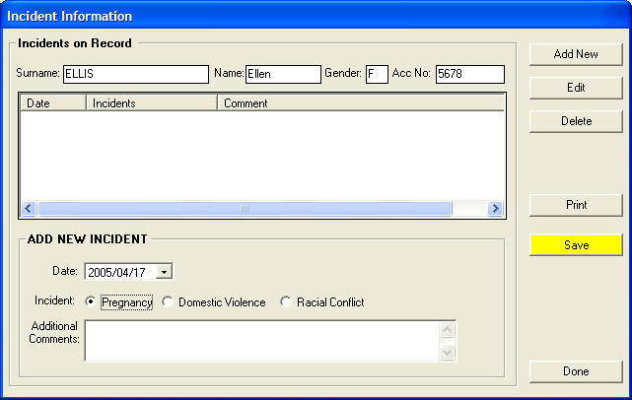
Figure 18: Incident Information

- Click on Incident under Learner Enrolment;
- You can add, edit, delete and print on this form;
- Incidents, other than disciplinary, can be recorded here; and
- Save any data entered.

2.1.6 Learning Barriers
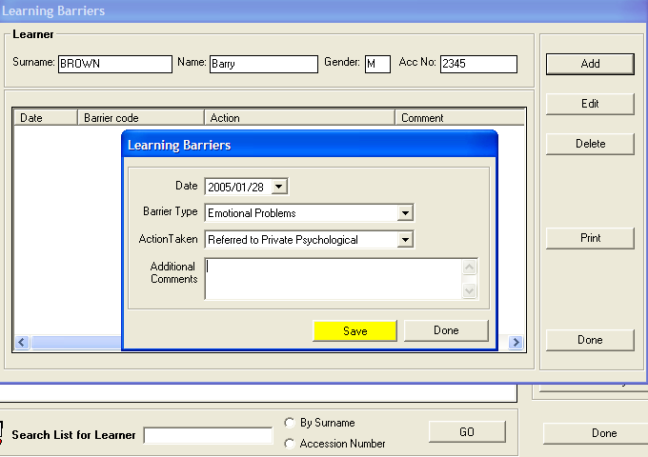
Figure 19: Learning Barriers

- Records of learners with Learning Barriers are kept so that the learner’s progress can be trailed;
- New educators the learner encounters can have access to these records and know how to cope with the learner;
- Click on the Learning Barriers button. Background screen will open. Any other barriers a learner may have will be listed in the list view;
- Click on Add to add new information. Front screen will open. Fill in information using dropdown menu. Save;
- To edit click on existing barrier in list view then click Edit button; and
- To delete barriers select an existing barriers and then click on Delete.

2.1.7 Sport, Art and Culture
The information captured here automatically populates the SA Tool once it is exported from SAMS

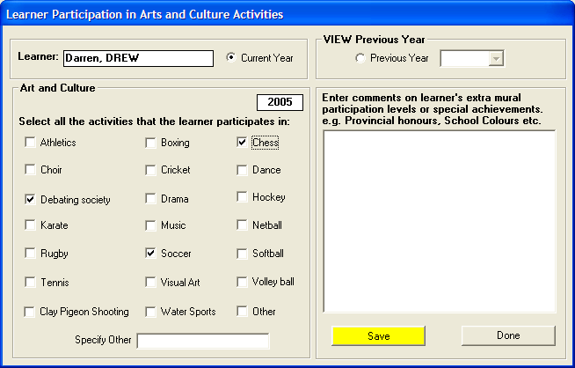
Figure 20: Learner Participation in Art and Culture

- Sport, Art and Culture activities that learners are involved in can be recorded here;
- To add, change or delete an activity from a learner click the Arts and Culture button to take you to the page;
- Tick in the box next to the relevant activity to add. Remove a tick to change learner’s preferences or to delete; and
- Remember to save your data always, by pressing the yellow Save button. Press Done to complete the task.

2.1.8 Marks Archive

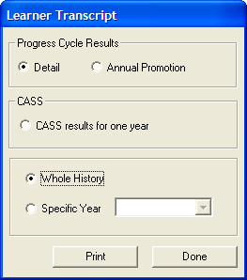
Figure 21: Learner Transcript

- The Marks Archive keeps records of all the marks a learner attained for all cycle tests or exams
- The marks would have been captured onto the system under the Curriculum Related Data module
- There are various selection options to print
- This provides a history of the learners attainments
- The transcript can be printed and produces a Learner Transcript

2.1.8.1 Marks Archive Printout
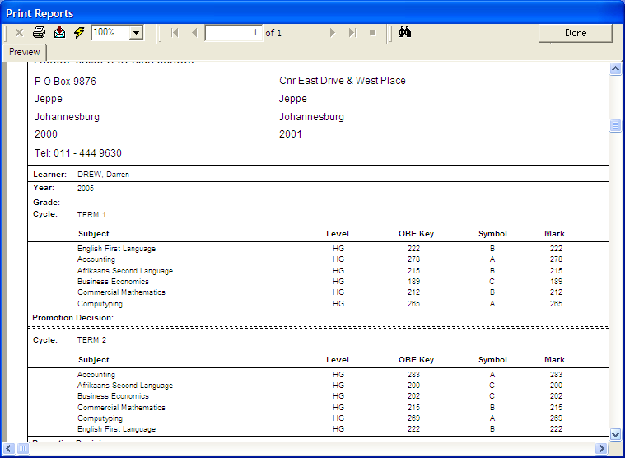
Figure 22: Marks Archive Printout

2.1.9 View Family

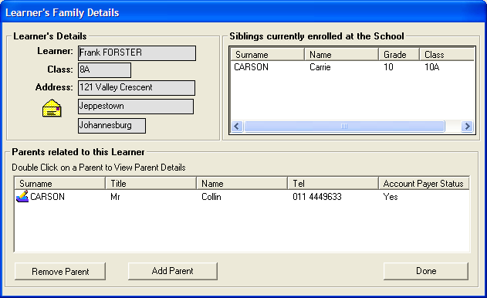
Figure 23: Learner’s Family Details

- In order to view the family structures of the learners in the school, (parents and siblings) you can either select the View Families button from the Learner Information menu or highlight a specific learner in the Learner Enrolment window and select the View Family button at the bottom right of the screen to view the selected learner’s family structure.

2.1.10 Update Parent Data
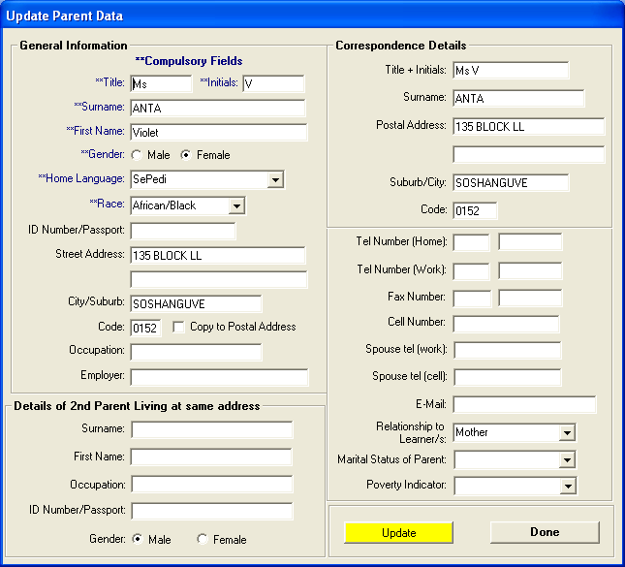
Figure 24: Update Parent Data

2.1.10.1 Updating or Viewing Parent Details

- Select the Parent Information button from the Main Learner Information menu.
- This opens the Parent Listing window. The parent list may be filtered according to the first letter of the parent’s surname. Select the desired letter from the drop down box to filter the parent list.
- To select a specific parent for viewing or updating, click on the name of the parent that you wish to update or view.
- Once you have highlighted the name of the relevant parent, select the Edit Parent Details button to view or update the parent’s details.
- Remember to Save your new data if you add to or change any of the details.
- A parent can only be deleted if there are no active learners on the system linked to the parent.
- Click Parent Information on the Learner Information Menu
- The Parent Listing per family window opens
- The Parent Listing per Parent page serves an important function as all active parents on the system are listed here
- Parents living together are listed separately for voting or counting purposes
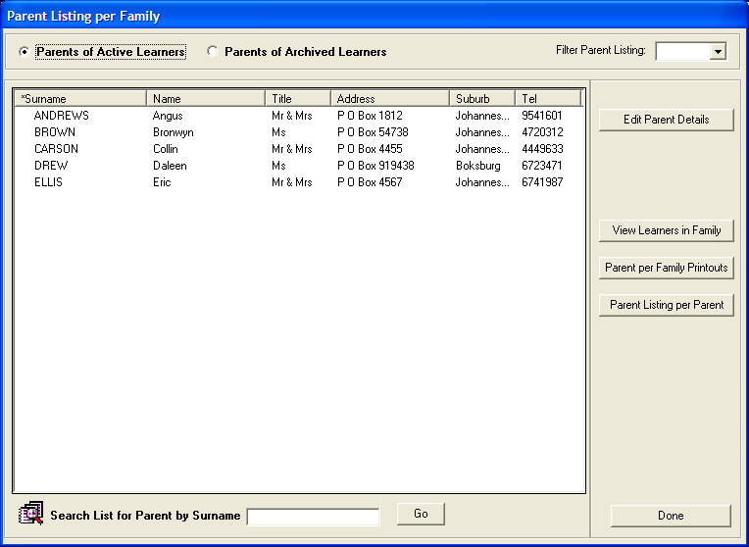
Figure 25: Parent Listing per Family

2.2 Learner Applications

- Click Learner Applications button from the Learner Information Menu (Figure 26 below.) to start the Learner Applications window. Figure 27 will appear.
Figure 26: Learner Information Menu

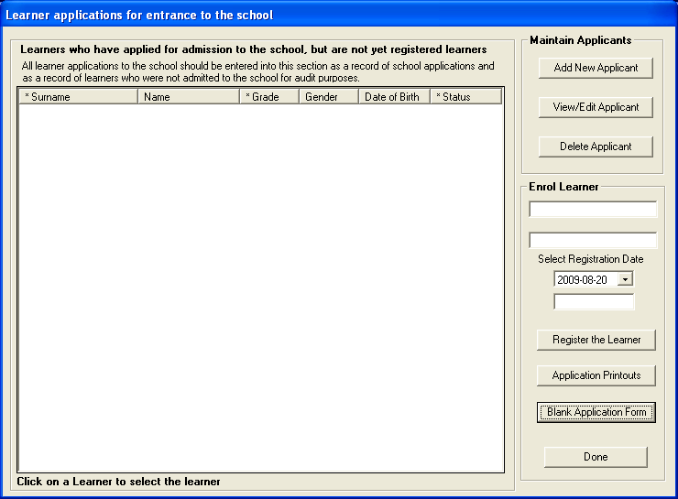
Figure 27: Learner Application for school entrance

- New learner applications for future admission into the school may be captured onto the system.
- This section is not to be used for current learners, but to record the details of applications received for admittance in to the school in the following academic year.
- Select the Blank Learner Applications button from the Learner Information menu to open the Applications window.
- The Blank Application Form can be printed and distributed to parents just before registration of new learners begins (see figure 28 below)
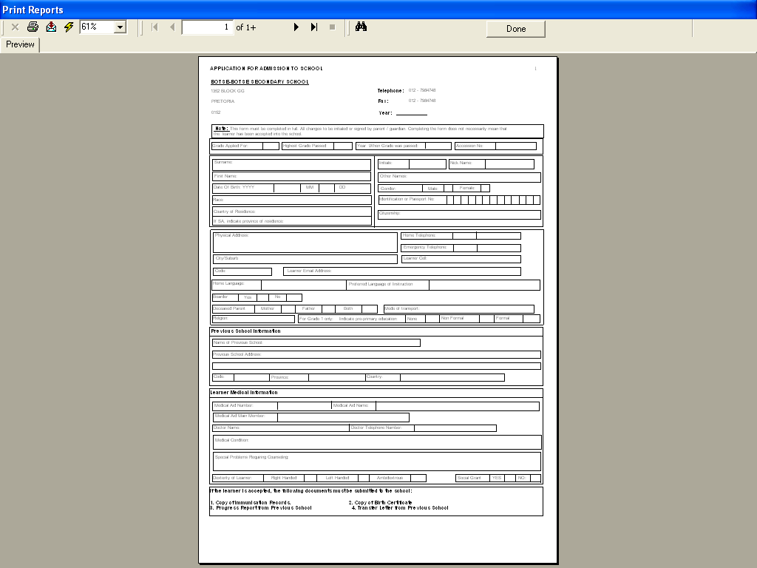
Figure 28: Blank Application form

Add a New Application

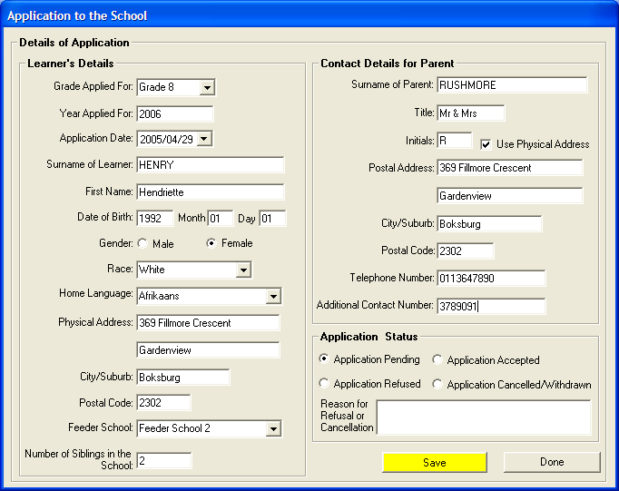
Figure 29: Application to the school

- Select the Add New Applicant button to open the data capture window.
- Complete all the learner’s details in the relevant fields and Save your data.

Updating or Viewing an Applicant’s Details

- In the Learner Application window, click on the name of the learner/applicant that you wish to update or view.
- Once you have highlighted the name of the relevant learner, click on the View/Edit Application button to view or update the learner’s details.
- Remember to Save your new data if you add to or change any of the learner’s details.

Status

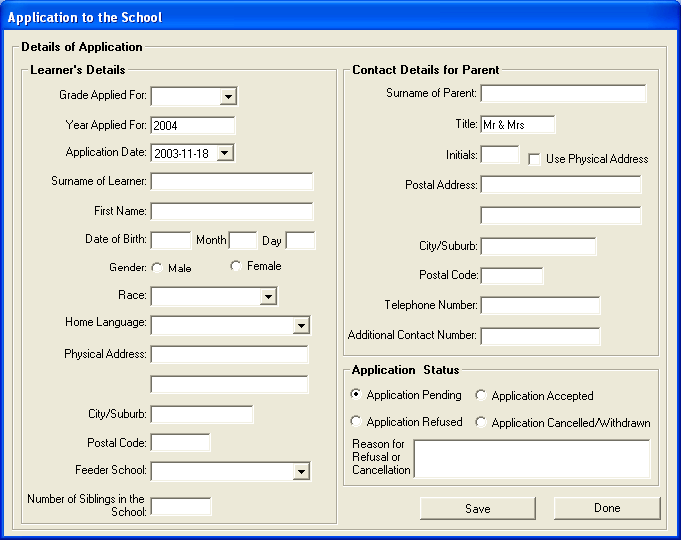
Figure 30: Status

- Users must capture the Status of the application when adding an application (see Figure 30 above)

Update an Application

- For accurate statistics on learner applications to the school, it is necessary to update the status of all learner applications on the edit form.
- Application will be pending until a learner has been accepted and the registration date into the school has been selected
- For applications that are refused or withdrawn /cancelled, click on the learners name and select either option.

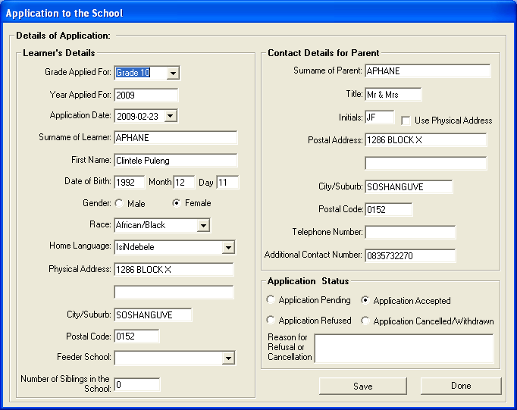
Figure 31: Edit Application

2.3 Learner Grade and Classes

- Click on Learner Grades and Classes button on Figure 2 above to open the learner Grades and Classes window, from this window, users can assign Grades and Classes to learners. (see figure 32 below)
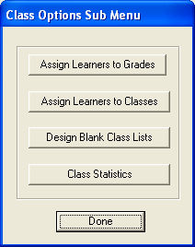
Figure 32: Class Options Sub Menu

Assign Learner to Grade

- These options are found on the Sub Menu once Learner Classes button has been selected.
- The option of assigning learners to classes is a time saving method of distributing learners, particularly after promotions have been done and all learners are just placed in grades.

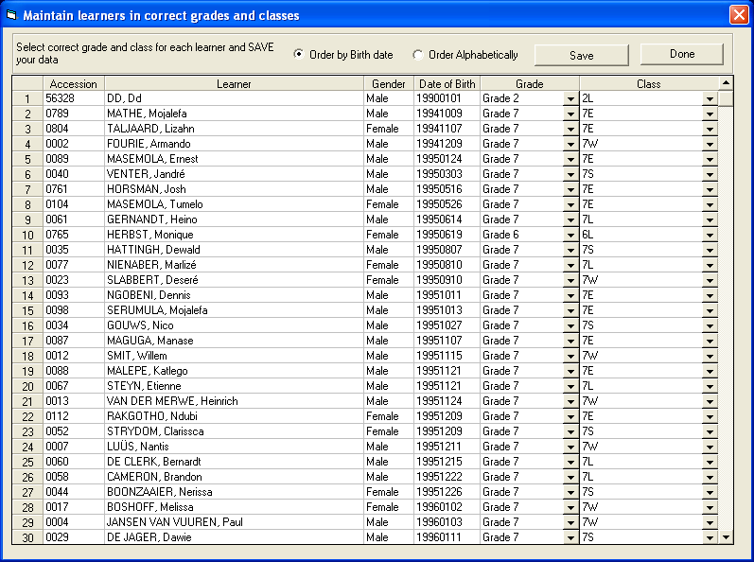
Figure 33: maintain learner in correct grade and class

- To assign learners to grade, follow the instructions given at the top of the screen.
- Click on a grade to work with by selecting the required grade from the Grade drop down list.
- Click on a class to work with by selecting the required class from the class drop down list.
- Repeat the above steps for all learner and put the on the relevant class and grade
- Once done click on the Save button.

2.3.2 Assign Learner Classes

- These options are found on the Sub Menu once Learner Classes button has been selected.

- The option of assigning learners to classes is a time saving method of distributing learners, particularly after promotions have been done and all learners are just placed in grades.

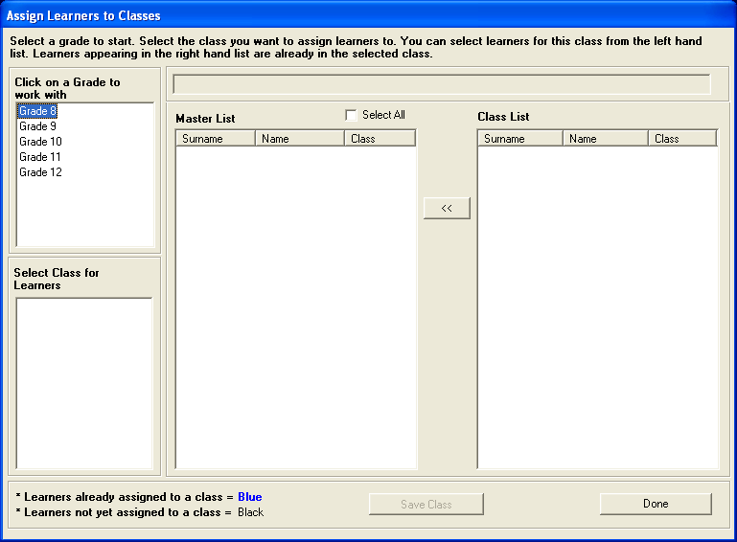
Figure 34: Assign Learner to classes

- To assign learners to classes, follow the instructions given at the top of the screen.
- Click on a Grade to work with by selecting the required grade from the Grade drop down list.
- The classes in this grade appear in the field below and the lists of learners in this grade appear in the Master List column.
- Click on the Class Name then select learners form the Master List to place in this class.
- The learners’ names jump over into the Class List column.

2.3.3 Design Blank Class Lists

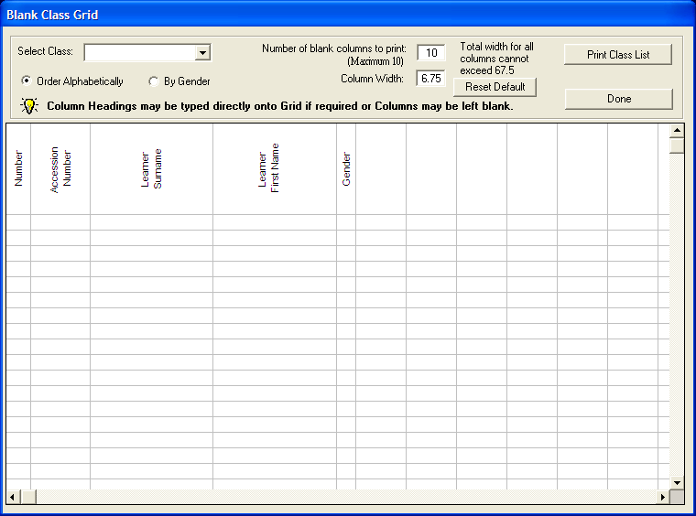
Figure 35: Blank Class List

- The above list can be utilized for a variety of functions at school level.
- Users can design the form specifically for the task at hand.

2.3.4 Class Statistics

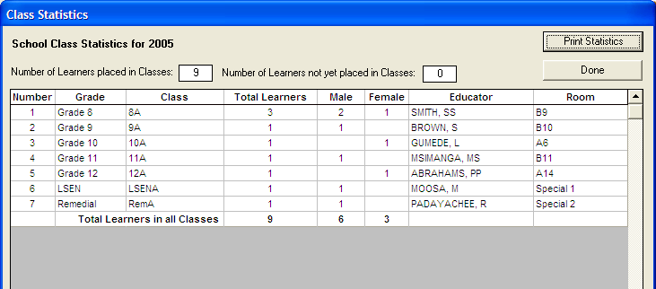Figure 36: Class Statistics

- The above statistics page is important for immediate requests for breakdown of learner information

2.4 SIAS for SNE Learners

Click on SIAS for SNE Learners button on Figure 26 above to open the SIAS for SNE Learners window, (See Figure 37 below)

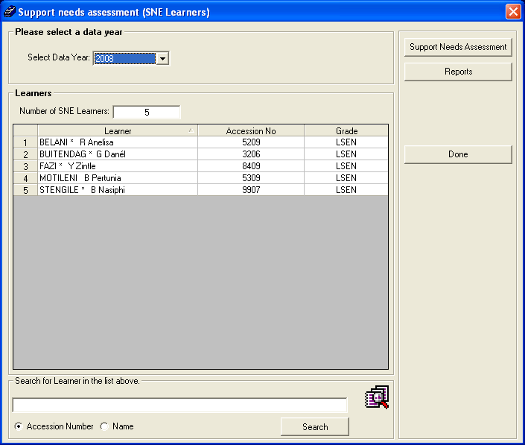
Figure 37: SIAS for SNE menu

- All SNE learner who have bee registered in the school can be assessed from this window
Note that tutorials for this manual have been captured in a separate manual

2.5 Parent Information

- Click on Parent Information button on Figure 26 above to open the Parent Information window, (See Figure 38 below)

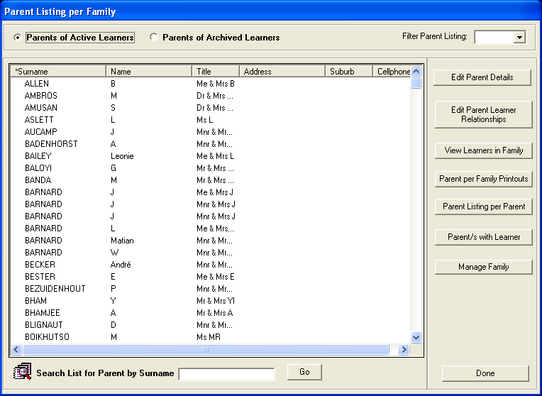
Figure 38: Parent information Menu

Parent Information

- Parent information can be edited using this system.
- To edit parents’ information, click on the Edit Parent Information button and the following menu will open

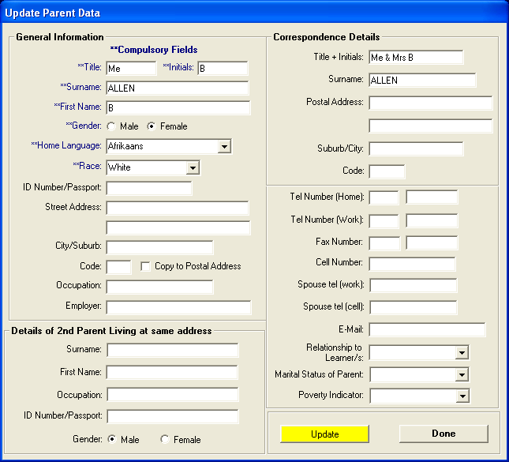
Figure 39: Parent information Sub Menu

- Change or edit the relevant parent information once done click on the Update button
- You can also use this menu to edit parent learner relationship; this gives you the option to choose the school fees payer for that particular learner
- To edit the parent learner relationship click on the Edit Parent Learner Relationship button and the following menu will open (Figure 40 below).

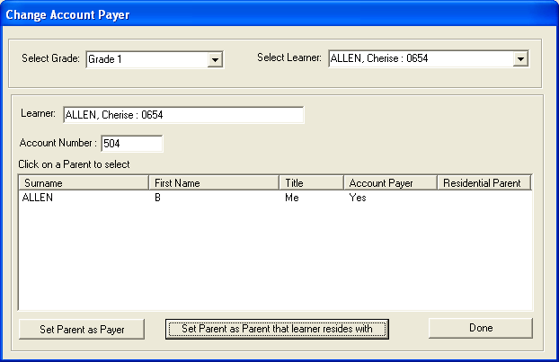
Figure 40: Parent information Sub Menu

- Select the Grade, Learner and click on the relevant option
- One can also use this menu to view learner in family at a glance one can be able to see a family that learner reside with, to view a learner family click on the view learner in a family button and the following screen will open

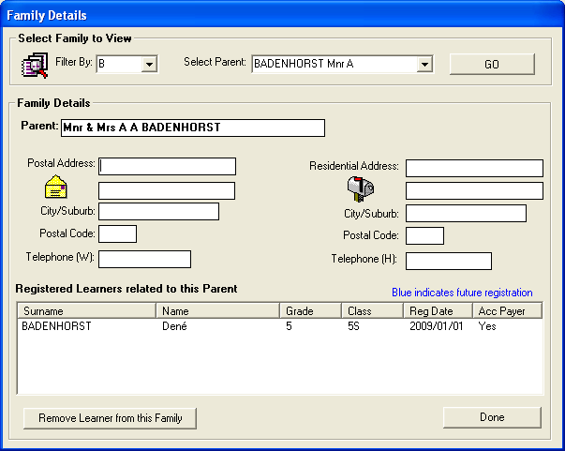
Figure 41: family details Menu

- Select the filter by option and choose and alphabet, choose a parent and then click on the yellow Go button, this will show you a registered learner related to this parent.
- The parent information menu also gives you an option to view parent per family printout to do this click on the Parent Per Family Printout button and the following screen will open

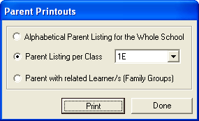
Figure 42: Parent printout Menu

- From the three option given choose the relevant option and click on the Print button
- The parent information menu also gives you an option to view a list of all active parents on the system
- To view the parents list click on the Parent Listing Per Parent button and the following screen will appear

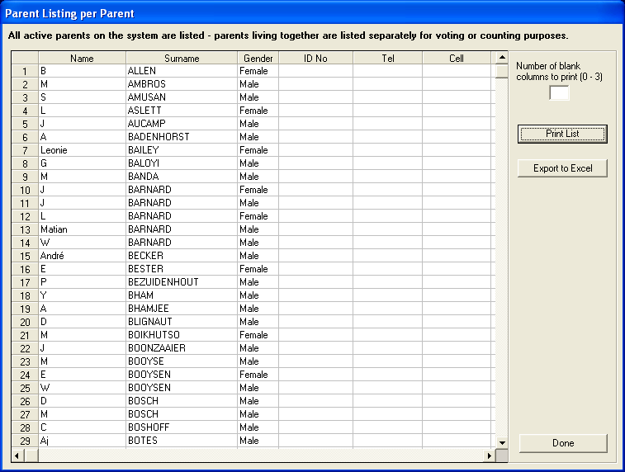
Figure 43: Parent information Sub Menu

- One can also use this screen to print a list of all active parents on the system
- The parent information menu also gives you an option to view a list of all parent with learner per grade
- To view this click on the Parent/s With Learner button and the following screen will open (See Figure 44)
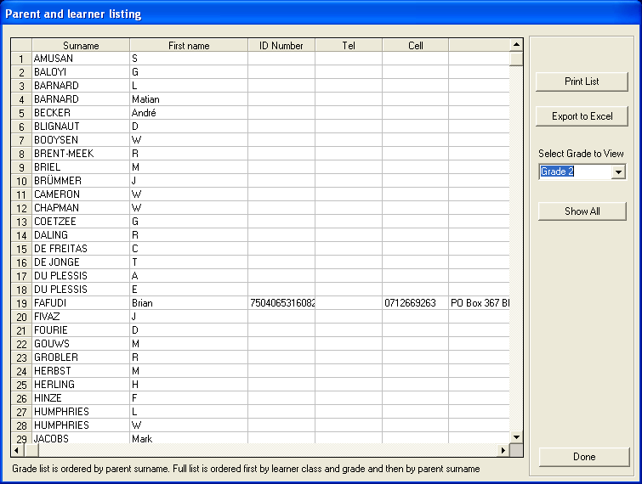
Figure 44: Parent information Sub Menu

- Select grade to view parent for from the Select Grade to View drop down and all parents active on the grade will be listed on the grid.
- The parent information also gives you an option to manage the family, one can use this option to remove a learner from the parent
- To remove a learner from the parent click on the Manage Family button and the following screen will appear (See figure 45 Below)

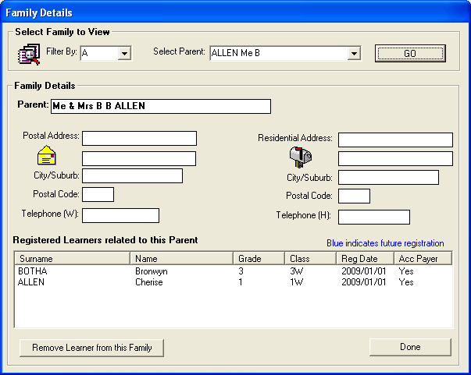
Figure 45: family details Menu

- Select an alphabet from the Filter By dropdown list box and select a parent dropdown list box and click on the Go button.

2.6 Learner Family Report

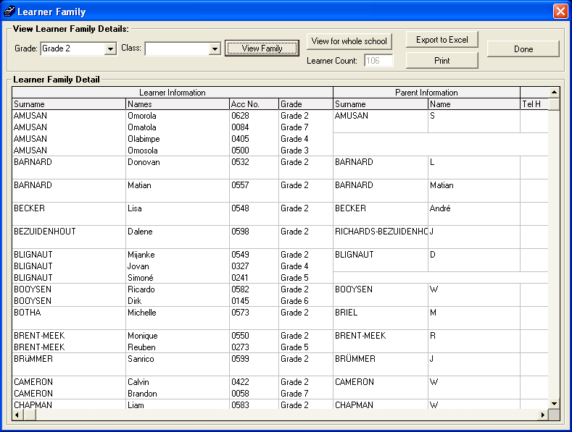
Figure 46: Learner family details Menu

- Learner family report allows you to view both learner and parent/s details; one can also be able to print the list of the family details.

2.7 Learner Parent Export

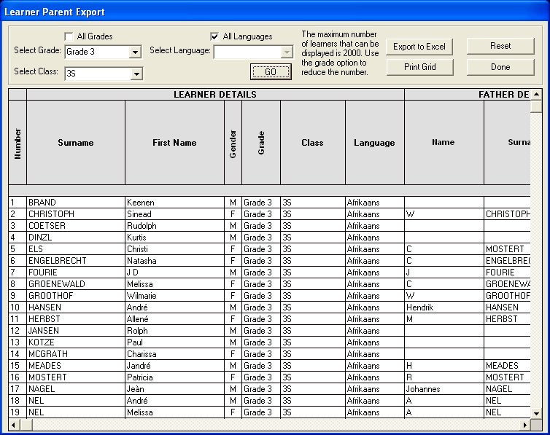
Figure 47: Parent expo Menu
- Learner parent export gives you an option to export the parent and learner details to excel.
- To export the parent and learner list to excel, click on the Learner Parent Export button and the above screen will open (See Figure 47)
- Choose the relevant option and then click on the Go button.

2.8 Learner Archive

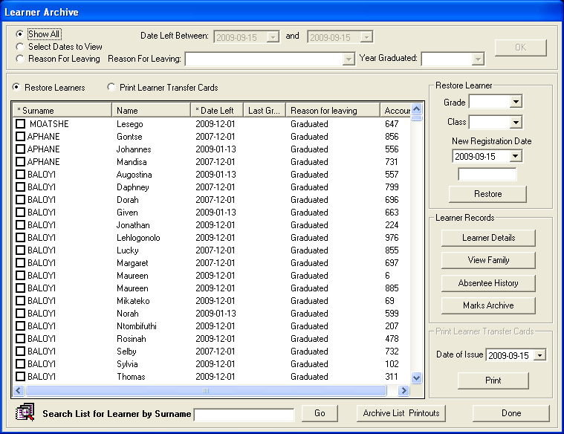
Figure 48: Learner Archive

- All learners who have left the school and have been archived are stored in this folder.
- Select Learner by checking the box next to the learner which you wish to archive from the Learner Archive list, select Reason for Leaving radio box, Select Reason for Leaving from the drop down menu, if reason for leaving is graduated select Year Graduated from the drop down menu.
- Select date from New Registration Date, if a leaner is registering for the first time.
- Should a learner wish to return to the school he/she can be restored
- Click in the box next to the learners name
- Complete the details under Restore Learner
- Click the Restore button once details have been completed
- Learner will appear under Current Learners list
- The buttons under Learner Records can be viewed as these give all the information that has been gathered about the learner that has been archived
- The Print Learner Transfer Cards gives a print out of the transfer certificate for learner. The transfer certificate should be issued to the next school at which the learner wishes to register.
- Click on Print Learner Transfer Card radio button, Select Date of Issue and click on Print to print the Learner Transfer card. (See Figure 49 below)
- The Archive List Printout gives a complete list of all archived learners between dates selected.

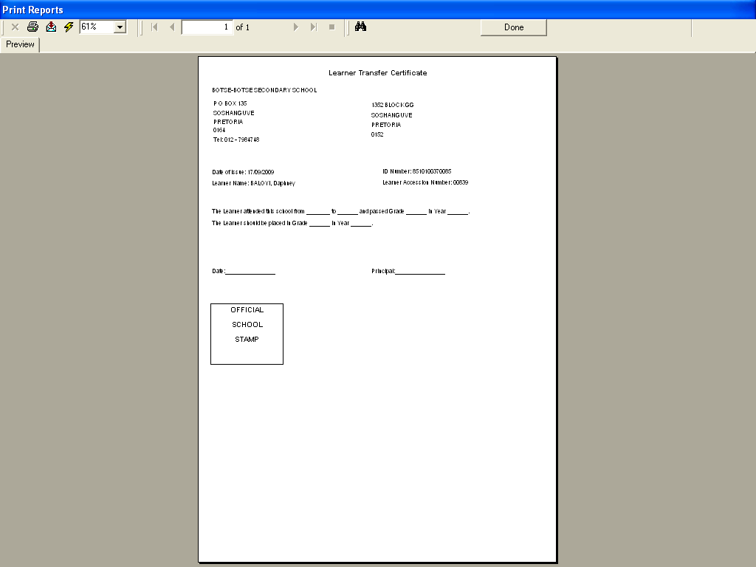
Figure 49: Learner Transfer Card

2.9 Delete Entire Learner Record

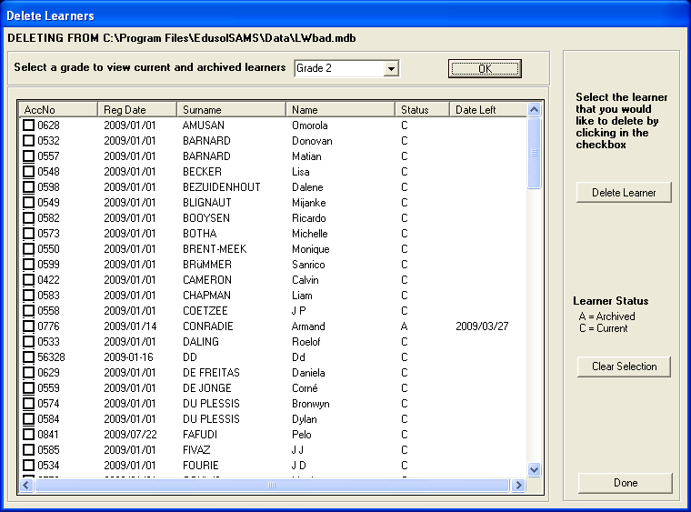
Figure 50: delete learner Menu

- Click the Delete Entire Learner Record button in the Learner information submenu to delete a learner from the program
- Select a grade click on the Ok button.
- Tick in the box next to the identified learner then click on the Delete Learner button.
- Learners can only be deleted if their financial records are up to date
- Click on Clear Selection to select the next learner
- Click on Done to exit

2.10 Maintain Attendance

- In this section, users can manage the attendance of learners per term.
- To open this sub-module , Click on Maintain Weekly Learner Attendance button from Learner Information window (see Figure 26 above).

2.10.1 Weekly Learner Attendances

- In Learner Information click on Maintain Weekly Learner Attendances.
- The Learner weekly school attendances will appear.
- Select a term and select the Week-Ending form the dropdown calendar.
- Click on Mark Attendance to mark weekly attendances.
- All classes are listed in red because none have been marked.
- Once a class has been marked for a particular week the class name turns black.
- There is a selection to mark the register alphabetically, when all names appear in this order, or by gender when list will open with males first.
- On this form you can also view or print detailed statistics per class.

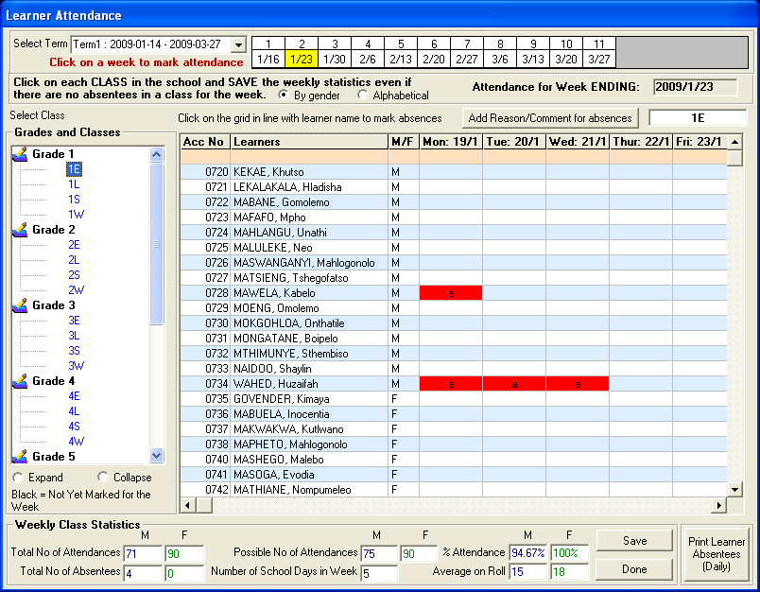
Figure 51: Learner Attendance

- Click on class name and a list of the learners will appear (See Figure 51)
- The days and dates for that week are listed across above the grid
- To mark absentees click in the grid line under the relevant day/date for the learner
- If there is a 100% attendance just click the Save button
- Weekly Class Statistics are indicated at the bottom of the page
- In instances where a user prefers to keep attendance records outside of the classroom there is the option to print a Blank Daily Attendance Register which can be selected for a month. The list has the learners’ names and the days of the month. (see Figure 52)

Blank Daily Attendance Register

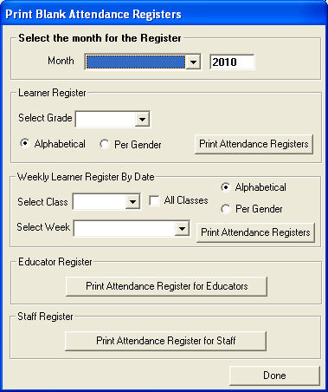
Figure 52: Print Blank daily Attendance register

Print Daily Absentee

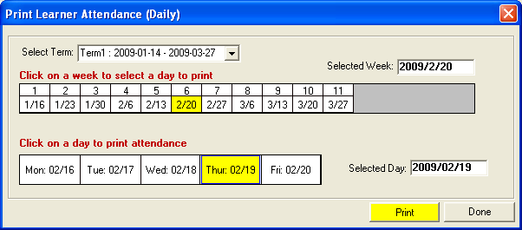
Figure 53: Print Learner Attendance (Daily)

- Select Term view learners
- Click on a week to select a day to print
- Click on a day to print attendance
- Click on the yellow Print button

View Individual Learner Absences

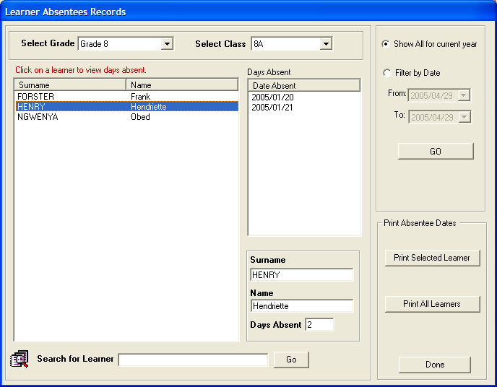
Figure 54: Learner Absentees Records

Learner Absentees Records
- Select Grade and Class to view learners
- Click on learner to view days absent
- You can also view by Filter by date
- You can print absentee dates using the Print Selected Learner and Print All Learners buttons.

Learner Attendance Printouts

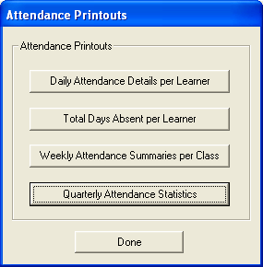
Figure 55: Attendance Printouts

- Click on Learner Attendance Printouts to print attendance reports using the options listed
- The Quarterly Statistics will be of particular interest to Education Officials

BELOW ARE THE VARIOUS SCREENS FOR EACH OF THE PRINT OPTIONS LISTED ABOVE

Daily Attendance Details per Learner

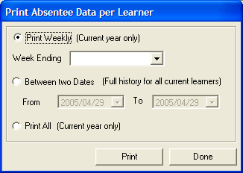
Figure 56: Print Absentee Data per Learner

- Click on Daily Attendance Details per Learner in Attendance Printout
- In Print Absentee Data you have three options
- You can choose to print per week
- Or between two dates
- Or you can just print them all
- You can only choose one option then click on Print button

Total Days Absent Per Learner

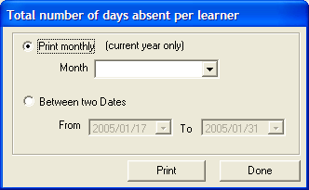
Figure 57: Total Number of days

- Click on Total Days Absent per Learner to print
- You can choose to print monthly absentees
- Or between dates

Weekly Attendance Summaries per Class

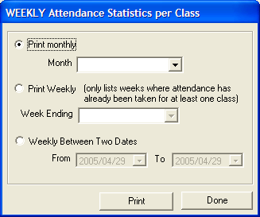
Figure 58: Weekly Attendance Statistics

- Click on Weekly Attendance Summaries per Class to print
- You can choose print monthly, weekly or between two dates

Quarterly Attendance Statistics

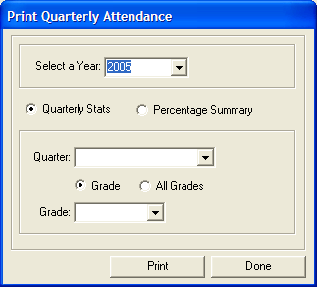
Figure 59: Print Quarterly Attendance

Quarterly Attendance

- Select Year
- Select one option at a time
- Quarterly Stats to print quarterly and
- Percentage Summary to print the percentage of attendances
- If you select Percentage Summary you’ll have two options to print per grade or all the grades.

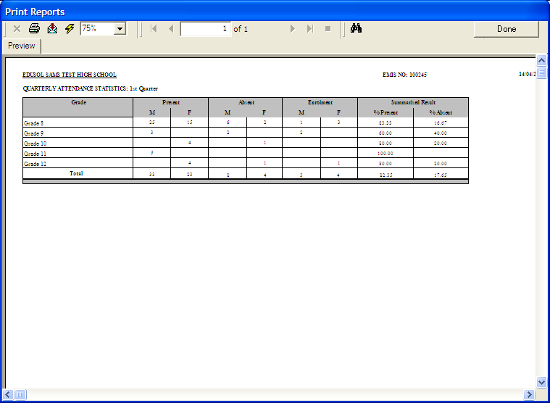

Figure 60: Print Quarterly Attendance Reports

- Keeping quarterly attendance statistics, for educators, other staff and learners is part of the administrative functions of a school and have to be completed because these statistics are required by the Education department

Export File for Learner Attendance

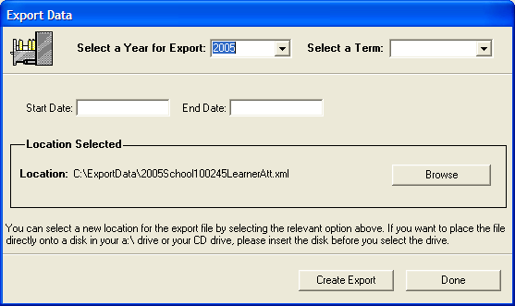
Figure 61: Export file Menu

Statistical Data and Reports

This menu is specifically for printing learner report. It indicates all the printout options available under Learner Enrolment. Class Reports give two options for printing:

- Class lists populated with learner information
- Class lists with learner names only and blank columns which can be used at users discretion.

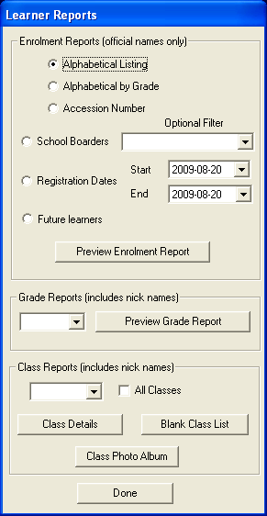
Figure 62: Learner Reports

Learner Age+ House Group List

This menu is specifically for printing Age Group List of learners. It indicates all the printout options available under Learner Enrolment per age group. Age group Reports give two options for printing:

- School age group
- House age group

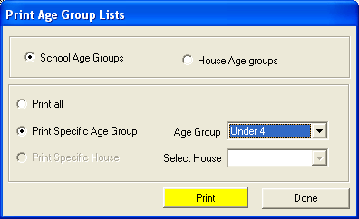
Figure 63: Age Group Printout Menu

Details of SNE Learner

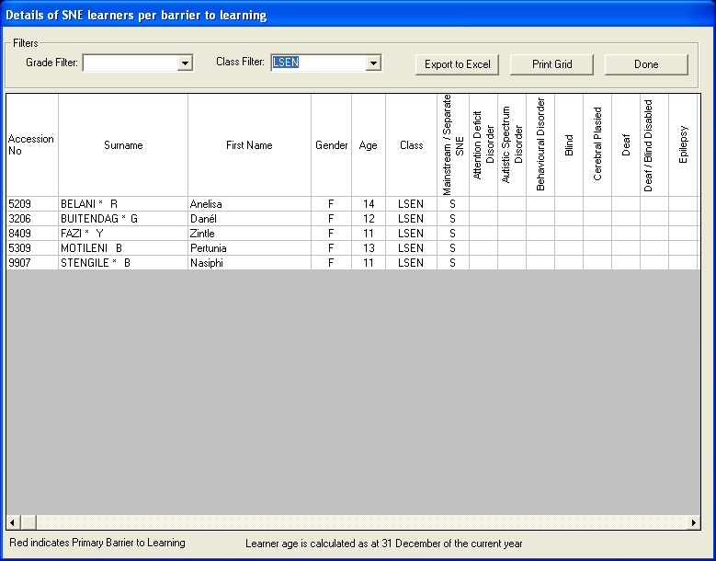
Figure 64: SNE learner details Menu

- Use the menu to view the details of registered SNE learners in your school
- To use this menu click on the Details of SNE Leaner button and the above screen will open
- Note that you can only use this menu if you have SNE learner in your school

Learner Details Data Printouts
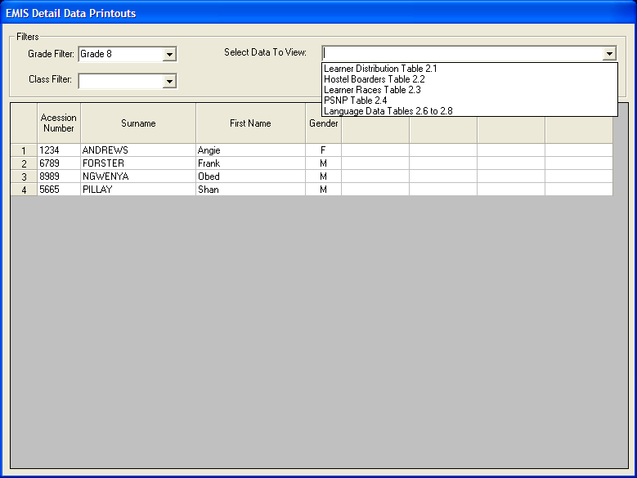
Figure 65: EMIS Details Data Printout

- The above page supplies the data to view in the dropdown box at top right
- All the data in the dropdown box is data that is required to complete the Annual School Survey
- If all data fields for learners are completed in the capturing of Learner Information these statistics are automatically populated as a result of the linkages in the programme
- This data can be exported to Excel
- EMIS data per learner is readily available

Learner Aggregate Data Printout

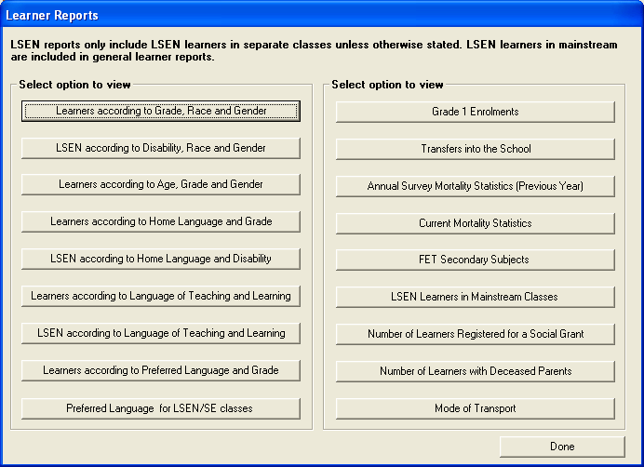
Figure 66: Learner Reports

- The Print options within the programme are phenomenal and can produce the following data:
  - To keep the schools’ record keeping current
  - To have information on hand to inform decision-making at management level
  - To deliver to the Education Department current data on request
- Each of the tabs above have a printout to view aggregated data on learner information
- All EMIS data is captured under Learner Information and populates these aggregated reports

Export File

- Click on Export Learner Attendance in Learner Information Menu
- Select a year and a term for Export
- This export function is to export, via email, your attendance statistics up to the web-based Department EMIS so that at provincial level officials would be able to view learner attendance at school level
- Click on Create Export
- Such statistics are normally requested by the Education Offices.

Customised Learner Data Fields

Learner Bus Route

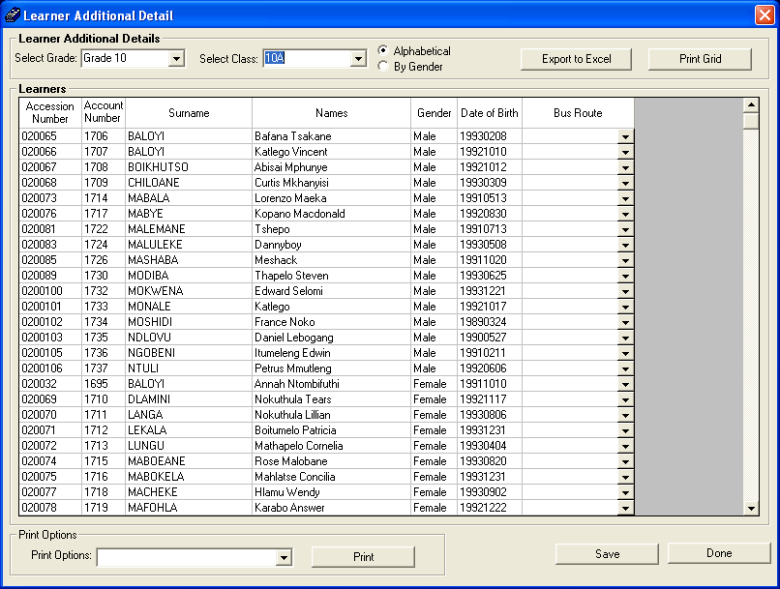
Figure 66: Learner Bus Route

- You can use this menu to assign learner to a particular bus route
- Remember that the bus route needs to be captured under the general school information
- You can also use this menu to print a list of learners and their bus route

Assign Mentor to a Learner

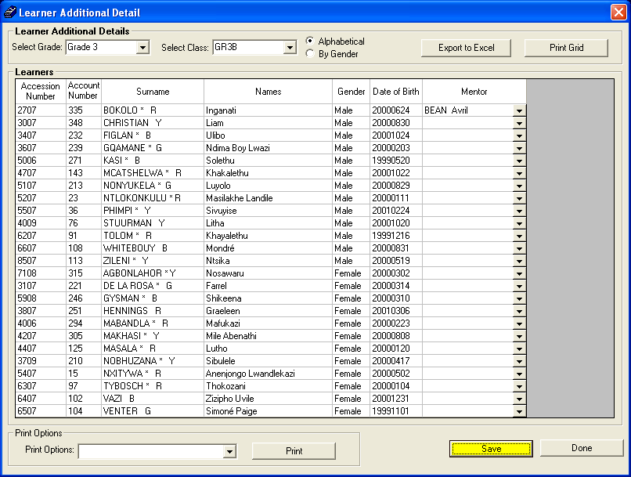
Figure 67: assign mentor to a learner Menu

- Use the above menu to assign a mentor to a learner.
- To assign mentor to a learner click on the assign mentor to a learner button and the above window will open.
- Select the Grade and Class to you wish to assign learner with a mentor.
- From the Mentor dropdown list select the educator and then click on the Save button.

Reporting Language

There are two language options that can be selected by schools for REPORTING purposes: English or Afrikaans. By reporting is meant the printouts, e.g. The end of term reports to parents, the fee statements that parents receive. Should schools choose to do their reporting in Afrikaans, these steps should be followed:

Setting up Afrikaans for Reporting Purposes

Step 1: Adding Afrikaans names for subjects

- Click on General School Information button on the Main Menu
- The General School Setup menu opens and Select School Subjects
- There are two tabs at the top of the screen Subjects offered by the School and Master Subject List. Click on Subjects Offered by the School
- The OBE Learning Areas are already loaded; choose FET subjects from the Master Subject List
- To add Afrikaans names for subjects, click on the subject in the school list
- Click on Edit School Subject button. The screen opens
- The English name for the subject appears in the top field
- Type in the Afrikaans name in the relevant field
- Select the correct phase within which the subject falls (Senior, FET)
- Save
- Follow this process for all subjects that must get Afrikaans names
- The print screen in the background shows both English and the Afrikaans names that have been added

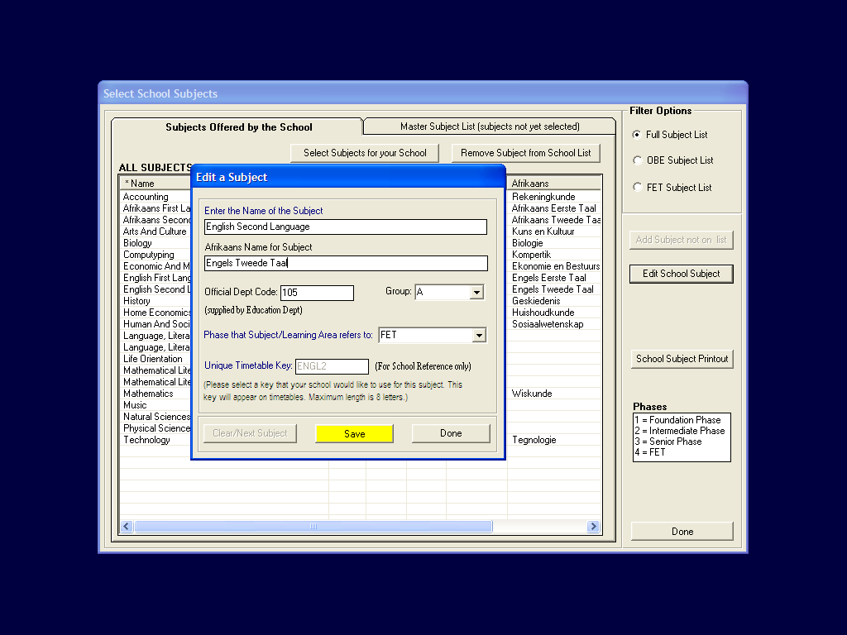Figure 68: Select School Subjects

Entering of NEW Learners onto the system

- Click on Learner & Parent Information on the Main Menu
- Click on Learner Information button. Learner Enrolment page opens
- Click on Add new Learner. Add information for new learner
- On the right of the screen is the option to select Reporting Language for the Learner
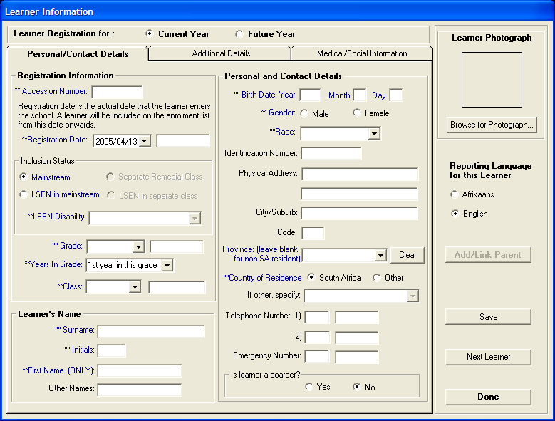
Figure 69: Learner Information

Changing existing learners reporting status on the system

- On the Learner Information Menu on the right of the screen there is a tab for Reporting Language per Learner. Click on this button
- The screen below opens
- You can select a language for the whole class, or you can select individual language per learner

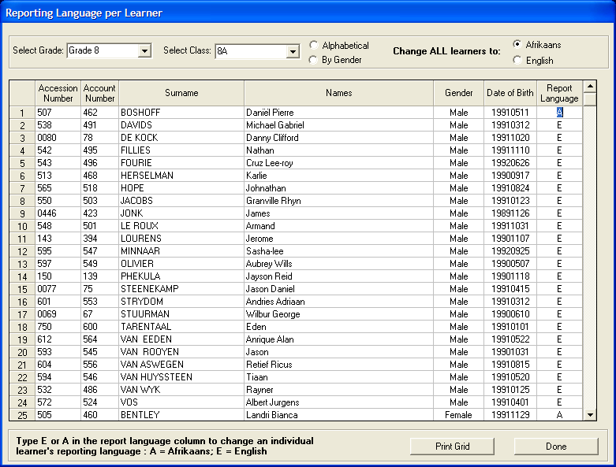 Figure 70: Reporting Language per Learner

Changing Reporting Language under Curriculum Related Data Module

- Click on Curriculum Related Data on the Main Menu
- Click on Setup Subjects and Subject Choices
- On the right of the screen click on Maintain Subject/Learning Areas
- There is an opportunity here as well to add Afrikaans names for subjects
- The second button on the right, Maintain Learner Report Languages, provides another opportunity to choose the learner’s reporting language
- On Curriculum Assistant menu, click on Maintain Learner Progress Reports
- The top right of screen has the following three buttons that also require Afrikaans names to be entered. They are:
  - Maintain Progress Report Cycles
    - If new Cycles - Add
    - If Existing Cycles - Click on Cycle, Edit Cycle, Afrikaans in Afrikaans

  - Maintain Evaluation Keys
    - Click on Description, Edit Description, Type in Afrikaans

  - Maintain Promotion Decisions
    - Click on Description, Type in Afrikaans

- The processes for Afrikaans name changing for the above three bullets is explained under the Curriculum Module

Year End Learner Promotions

- Click on Process and Maintain Learner Promotions in Learner Information Menu in Figure 26.

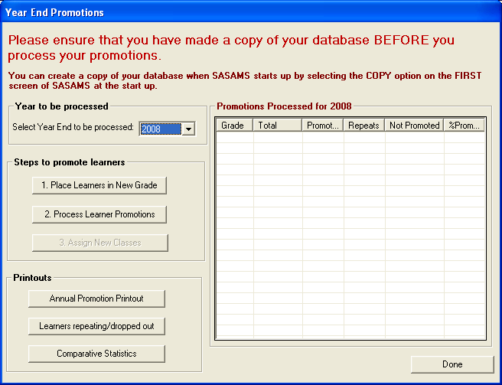
Figure 71: year end promotion Menu

Process and Maintain Learner Promotions

- Select Year that needs to be Processed
- Click on 1. Place Learners in New Grade to Promote or Not to Promote learners (Fig 72 opens).

Place Learner in New Grade
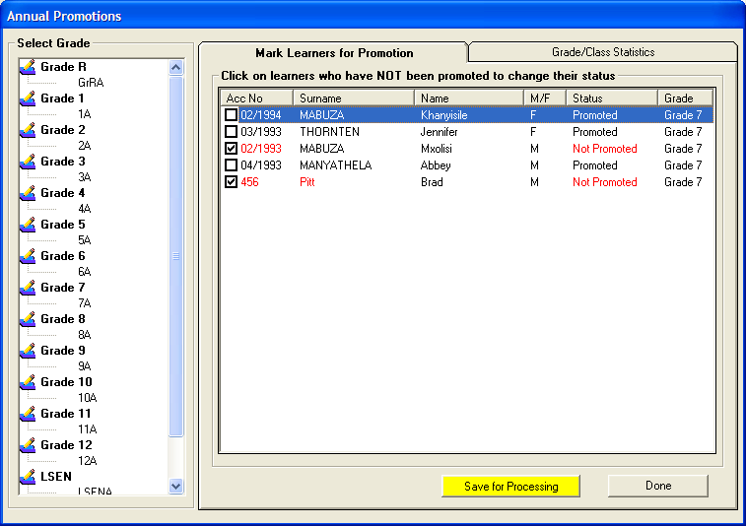
Figure 72: Annual Promotions

- Click on the Class name and the learner list appears
- Tick only the learners in the class that are not promoted/repeating the grade
- The following screen appears

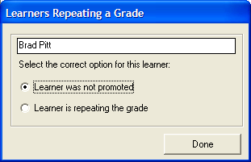
Figure 73: Learner Repeating a Grade

- Select the correct option
- Click Done. The name of the selected learner/s will appear in red with the status indicated alongside the name/s
- Follow this process for all learners in each class in each grade who are not promoted
- Once this step is complete
- Click Save for Processing (Fig 138.)
- Do this for each and every class in the school

Grade Class Statistics

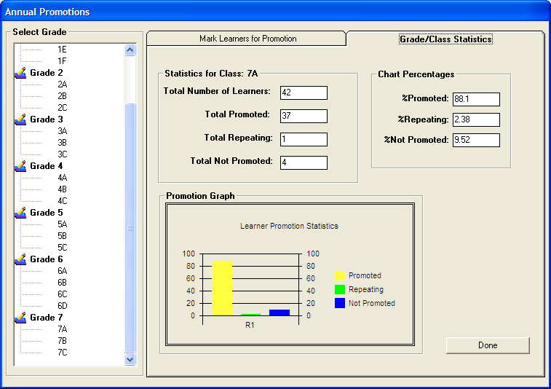
Figure 74: Annual Promotions

- Once the promotions for each class or grade have been completed, you can click on the Grade/Class name in the tree view to view the statistics on the page Grade/Class Statistics
- Once all classes have been saved for processing
- Click 2. Process Learner Promotions to process the promotions

Process Learner Promotions

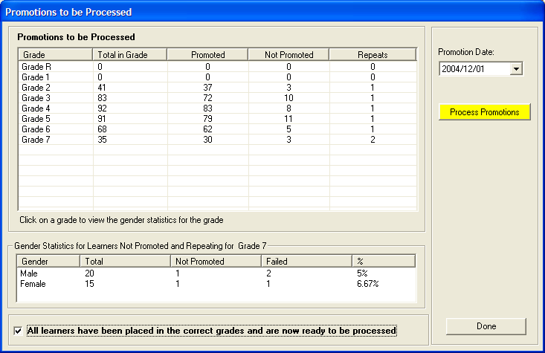
Figure 75: Promotions to be processed

- The screen picture above indicates the promotion statistics for each grade
- At this point educators can check that their promotion figures are correct
- Once figures have been checked for accuracy, tick in the box at bottom of screen All learner have been placed in the correct grades and are now ready to be processed
- Select Promotion Date and click the yellow button Process Promotions
- Your year end promotion screen will now indicate the promotions processed for that year

Promotions Processed

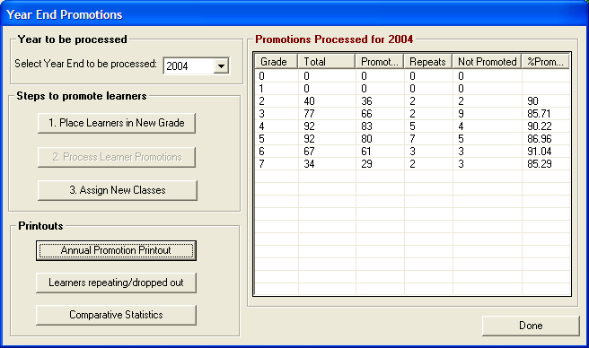
Figure 76: Year End Promotions

- Click 3. Assign New Classes to assign new classes to learners
- The screen below will open.

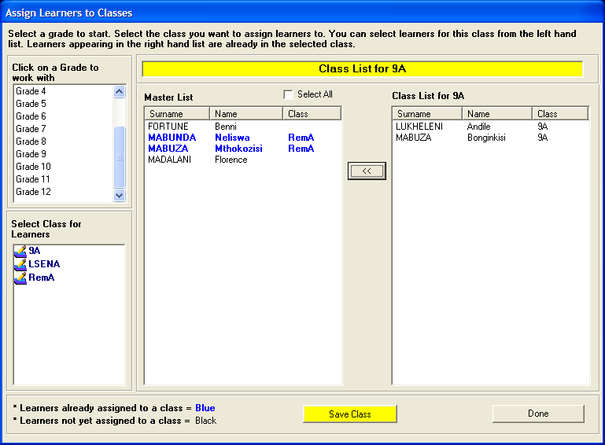
Figure 77: Assign Learners to Classes

Annual Promotion Printout

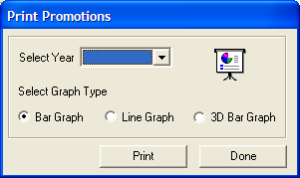
Figure 78: Print Promotions

- Comparative statistics can be accessed by selecting the graph type required
- Below is a screen picture of promotion statistics in the Bar Graph

You can printout the promotion stats

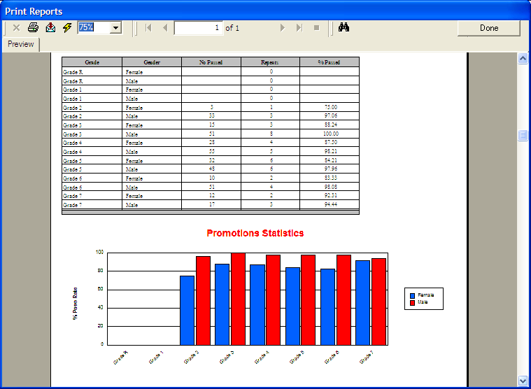 Figure 79: Print Reports

3. GENERAL REMARKS

Please note that Merit and Demerits (See Figure 2: Leaner Information window) Section was not covered in this manual. This Sub-module is covered in a separate manual as it is a substantial sub-module.

